

National College of Ireland

<Academic Year 2022/2023>

Aisha Ntuli, X21341006, X21341006@student.ncirl.ie

Jane Keyes, X22121358, X22121358@student.ncirl.ie

Karl Miller, X21522489, X21522489@student.ncirl.ie

Tadhg Savage, X21406654, X21406654@student.ncirl .ie

Cooktastrophe

Technical Report

Contents

Executive Summary 1

1.0 Introduction 2

1.1. Background 2

1.2. Aims 2

1.3. Technology 2

1.4. Structure 2

2.0 System 2

2.1. Requirements 2

2.1.1. Functional Requirements 2

2.1.1.1. Use Case Diagram 2

2.1.1.2. Requirement 1 <Name of requirement in a few words> 2

2.1.1.3. Description & Priority 2

2.1.1.4. Use Case 2

2.1.2. Data Requirements 3

2.1.3. User Requirements 4

2.1.4. Environmental Requirements 4

2.1.5. Usability Requirements 4

2.2. Design & Architecture 4

2.3. Implementation 4

2.4. Graphical User Interface (GUI) 4

2.5. Testing 4

3.0 Conclusions 4

4.0 Further Development 4

5.0 References 4

6.0 Appendices 4

6.1. Project Plan 4

6.1. Collaboration Summary 4

# Executive Summary

The key points of the following report are the introduction which includes the background detailing why we chose to undertake this project and other subsections aims, technology, structure which help to further detail our process in creating this idea. The report then moves into the system and its requirements, functional requirement, data requirements, environmental requirements, usability requirements, user requirements then a section with a use case diagram , description & priority, design & architecture, implementation. GUI ( Graphical User Interface) which details what exactly can be seen in the scenes of our game. Then testing of how we tested our VR game a conclusion of for what we have done so far and a plan for further developments we would make given more time and resources all appropriate references an appendices section for information relevant to the main body of report. The project plan we followed to help our idea come to fruition and finally our collaboration summary which provides evidence of our collaboration throughout the course of the project. The purpose of this report is create a easy to read, concise summary of our project idea especially to someone who may not have been following our idea from the beginning.

# Introduction

## Background

Most simply put we undertook this project to pass this module as it was literally a requirement but in terms of specifically why we decided to make the VR gaming experience that is “Cooktastrophe” we decided to undertake it because we wanted to create an app or game that would make it so anyone and everyone would be able to partake in it similar to the style of Wii Sports.

## Aims

The project aims to achieve a fun VR gaming experience for people of all ages.

## Technology

The technologies we will use to achieve what we have set out to do and how we will use them would be first using the Voxel 3D modelling program known as “Blockbench” which is also used by “Minecraft” for their games making our game have a similar retro style animation while still being modern and unique. We will also use “unity” the game engine which our game is made with. C# the language used to create Unity games. HMDs or head mounted displays the target hardware which is unique to the VR experience making it unique to our game. “Blender” which is a general use modelling software used to animate a select few models. Along with using various other technologies such as Github to share and update documents along with Word and Powerpoint for our presentations and WhatsApp for communication.

## Structure

In the executive summary we will outline a very brief summary of the project.

# System

## Requirements

In our application we have included a tutorial for users to understand how to play the game. The game itself is a simple concept that does not take too much effort to understand and play successfully. So upon finishing the tutorial and then playing the game a few times the player should have a complete understanding of how to play the game and be able to complete it with little to no errors.

## Functional Requirements

The functional requirements for our game in a ranked order would be as follows:

In terms of what the system must accomplish (the possible effects of a software system) this would be to successfully run through the game completely without glitches or crashing enabling the user to have an enjoyable time playing the game.

Other kinds of requirements (interface requirements, performance requirements and reliability requirements) such as the interface requirements would be having the system be fully responsive so that the user/player may perform game specific tasks being able to grab and hold objects or interact with other elements of the game such as completing cooking and clean up tasks or speaking to customers.

Performance requirements for the game would be for the system to run as smoothly as possible without interruptions.

Reliability requirements would include ensuring you have the right equipment and necessary connections for the game in order to avoid system failure.

This section lists the functional requirements in **ranked order**. Functional requirements describe the possible effects of a software system, in other words, what the system must accomplish. Other kinds of requirements (such as interface requirements, performance requirements, or reliability requirements) describe how the system accomplishes its functional requirements. Each functional requirement should be specified in a format similar to the following:

Short, imperative sentence stating highest ranked functional requirement.

## Use Case Diagram

## Requirement 1:Tutorial

## Description & Priority.

This requirement is to determine whether the user would like to play the game doing a tutorial first or if they would like to begin without it. It is essential to the overall system as it is one of the first steps the user takes in playing the game.

## Use Case

Each requirement should be uniquely identified with a sequence number or a meaningful tag of some kind.

**Scope**

The scope of this use case is to show what it would look like if a user decided to begin the game with the tutorial.

**Description**

This use case describes the process in which a user goes through when playing through the games tutorial.

**Use Case Diagram**

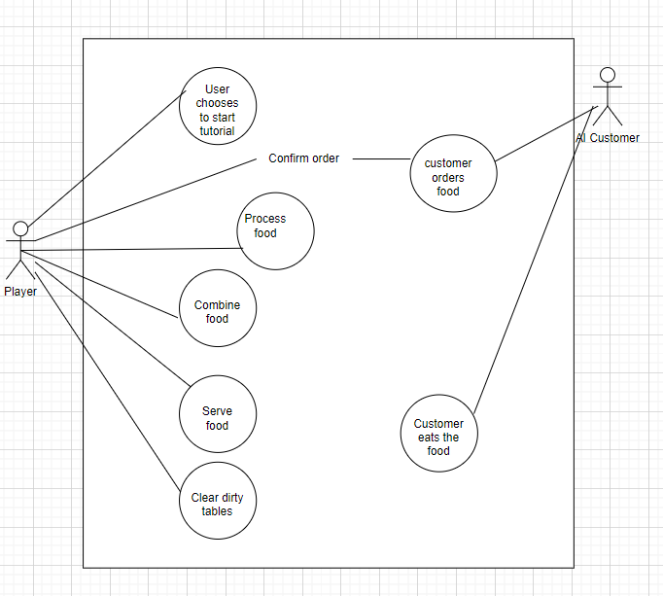

**Flow Description**

**Precondition**

The system is in initialisation mode the home screen is displayed while in a wait state where it waits for the user to either begin the game tutorial or begin the game without a tutorial.

**Activation**

This use case starts when an actor chooses the option to begin the game’s tutorial mode and from here the tutorial sequence plays out for the user to follow along to.

**Main flow**

1. The system begins in a wait state waiting for the user to begin tutorial mode or begin the game straight away.
2. The system identifies the actor has initialised tutorial mode and begins the tutorial.
3. The <Actor> then plays along with the tutorial.
4. The system runs through the tutorial until the end.
5. The <Actor> is then given the option to do the tutorial again or begin the game

**Alternate flow**

A1 : <Alternative1 >

1. The <Actor> never chooses what they want to do leaving the game in a continuous wait state in which nothing is ever initialised.
2. The system responds by staying in its wait state.
3. The use case continues at position 3 of the main flow

**Exceptional flow**

E1 : <Exceptional1 >

1. The system can not display the home screen as the VR headset is not connected so the user is not able to pick between the tutorial and begin game.
2. The <Actor> the user must connect the VR headset to begin the game.
3. The use case continues at position 1 of the main flow.

**Termination**

The system then terminates the tutorial by running through it until the tutorial is finished.

**Post condition**

The system goes into a wait state.

## Data Requirements

The user may choose to save game data and continue with previous progress but it is not necessary and they can start a new game each time. It is not imperative to the game that the user starts the game with saved data.

## User Requirements

The are no necessary user requirements for the user to be able to play the game other than to be able to have a general understanding of it.

## Environmental Requirements

The only environmental requirements would be to have a fairly big open space to be able to play the game without bumping in to anything to avoid injury.

## Usability Requirements

The usability requirements of the game are to have a VR headset to be able to play the game.

## Design & Architecture

The design of the game is a simple Voxel art style taking inspiration from retro 8-bit style games like Pacman while also still having a sense of modernity within them like games such as Minecraft. Simple yet appealing, eye catching but not distracting as we like to put it. The colour choice also being bubbly and bright to bring a warm light-hearted atmosphere to the game along with the upbeat background music. We wanted the game to feel retro yet modern, nostalgic yet fresh.

In terms of the system architecture, we designed it so that the restaurant is the only pace that the player works from. The player has everything they need within close proximity to them and doesn’t have to make a lot of effort to get the items that they need in order to complete their tasks behind the counter is where they greet customers and take orders along with it being the food preparation, cooking and clean-up area for the restaurant’s dirty dishes.

The components we used were the ones we created ourselves with C Sharp scripts along with ones that came with the engines and various packages that unity provides.

The scripts we used were: <insert named C Sharp scripts>

<Insert specified algorithm>

Describe the design, system architecture and components used. Describe the main algorithms used in the project. (Note use standard mathematical notations if applicable).

An architecture diagram may be useful. In case of a distributed system, it may be useful to describe functions and/or data structures in each component separately.

## Implementation

Describe the main algorithms/classes/functions used in the code. Consider to show and explain interesting code snippets where appropriate.

## Graphical User Interface (GUI)

Provide screenshots of key screens and explain what can be seen in each one.

## Testing

One of the main tools used for testing the game was a VR headset as this is a VR game made to be played exclusively in its VR format.

# Conclusions

Describe the advantages/disadvantages, strengths and limitations of the project

Some of the disadvantages and advantages, strengths and limitations we had when executing this project were firstly our individual skill sets. Each team member possessed different yet key skills which helped us achieve our final result. Tadhg has the most experience in creating games from designing them to coding them. With this knowledge he helped the rest of our team to develop our own understanding of creating games and led us through the process of making the game in various aspects. Karl also had a good understanding of making games but was particularly skilled in 3D Modelling which we used to develop the objects and people you see in our final game. Karl led Jane and I in learning how to 3D model using Blockbench’s software and directed us to some useful resources to help expand our knowledge in modelling. Jane had experience in software engineering and project management while I had experience in documentation writing and project planning. We all possessed different strengths in relation to the project. We had many advantages like Tadhg being so skilled at creating games but a lot of our limitations lied within that fact and as a group we had to do a lot to catch up and become better versed with the world of game making to be able contribute more to the project. Although through our persistence and will to learn we were able to contribute equally through developing skills that we were lacking in which we could say is another one of our strengths.

# Further Development

With additional time and resources we as a team would love to be able to see our project go in the direction of our business plan as outlined in our idea sketch pad and our mid-point presentation slides. An initial release on Steam along with a free trial. Satisfactory sales making it possible to push the game onto to multiple platforms such as PlayStation and Xbox. Downloadable content in the future along with timed events and themed elements to the game for different holidays such as seasonal décor such as easter wreaths and seasonal dishes like turkey for Christmas. Special collectors bundles, more kitchen layouts and paid cosmetics for changing the style of your kitchen. With more time and resources available we would love to take this game as far as we could.

With additional time and resources, which direction would this project take?

# References

Please include references throughout your document where appropriate. See [here](https://libguides.ncirl.ie/referencingandavoidingplagiarism) for a guide on referencing from the NCI library.

# Appendices

This section should contain information that is supplementary to the main body of the report.

## Project Plan

## Collaboration Summary

Summarise and provide evidence of collaboration throughout the project. Evidence may take the form of Trello boards, Chat logs, Git Logs etc.

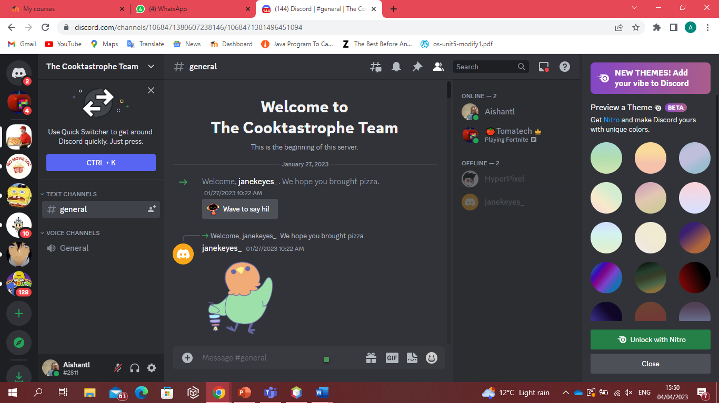

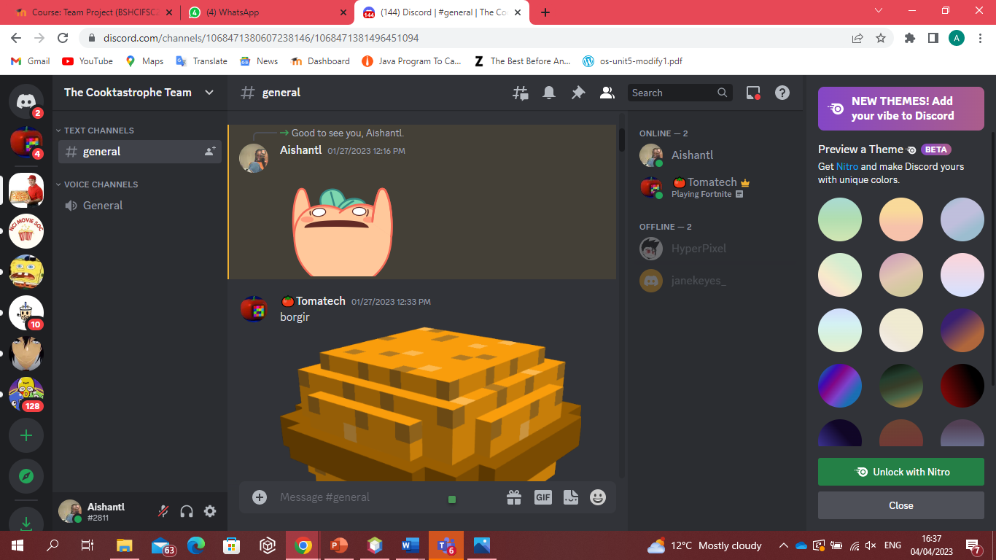

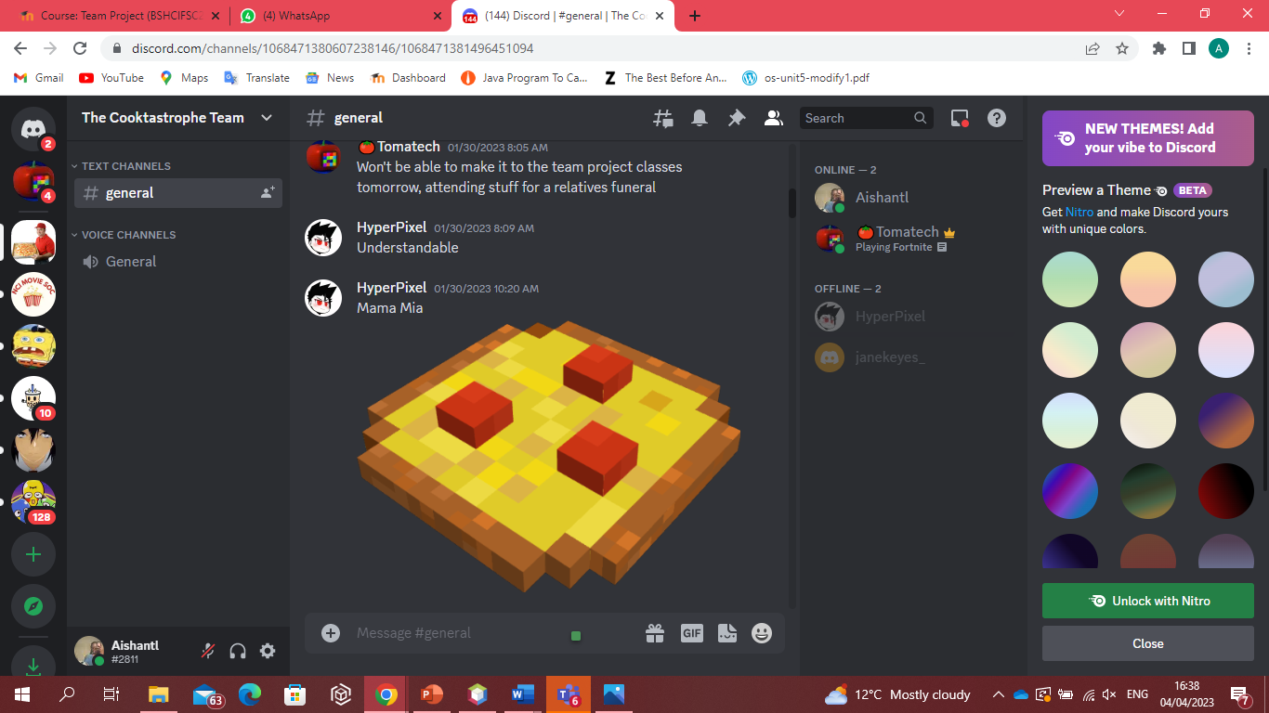

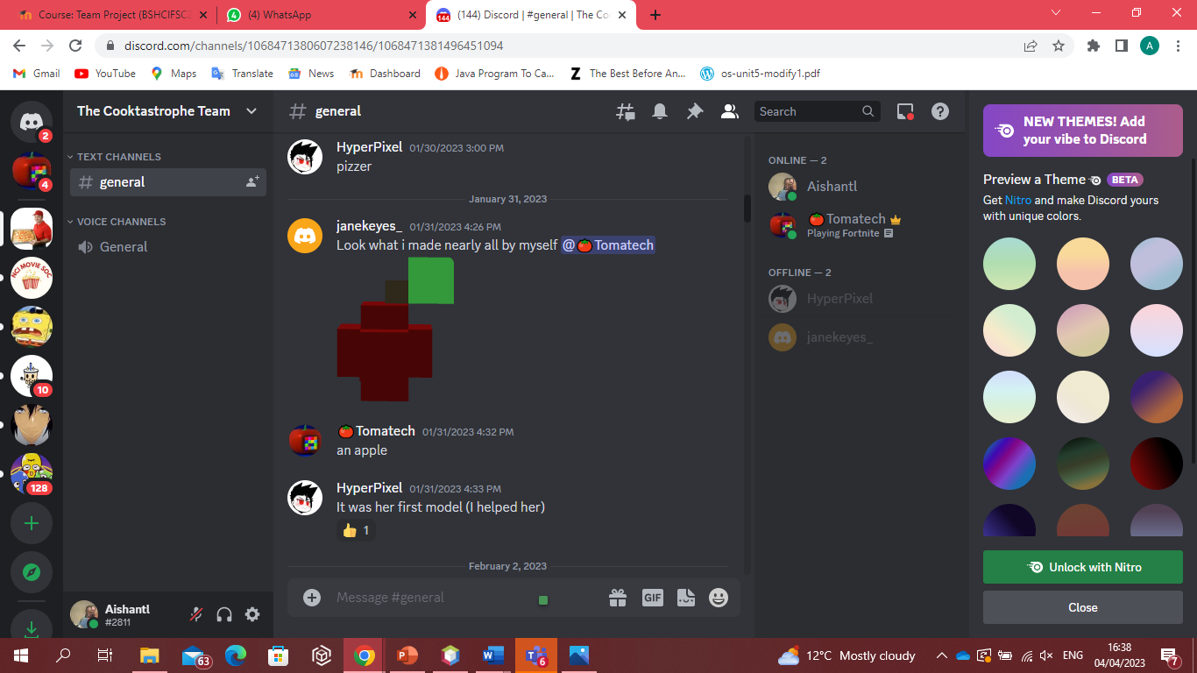

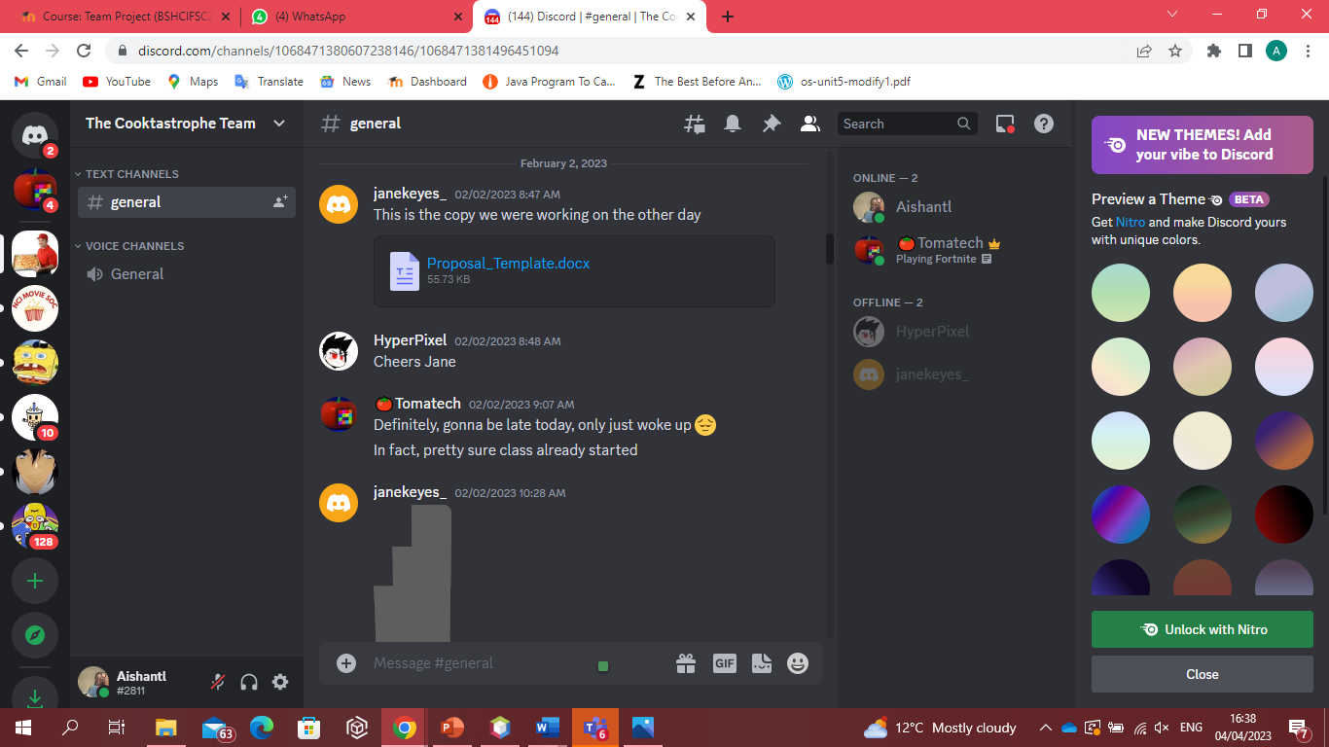

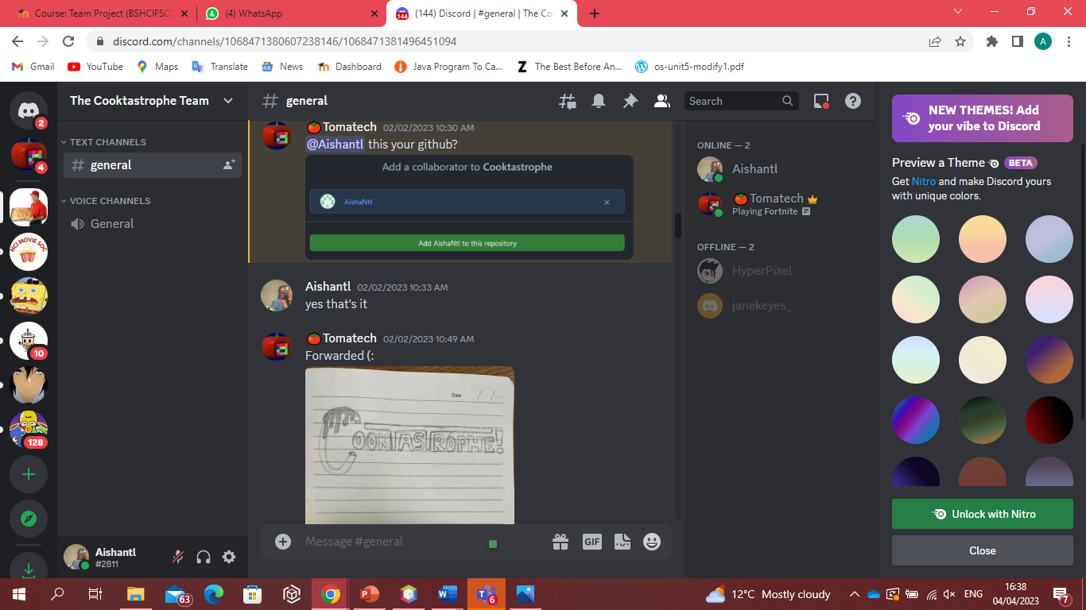

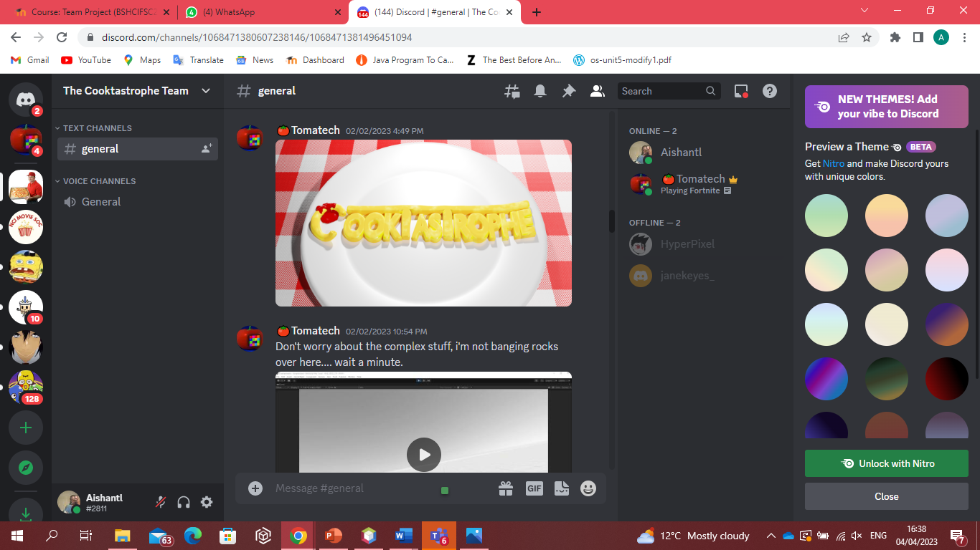

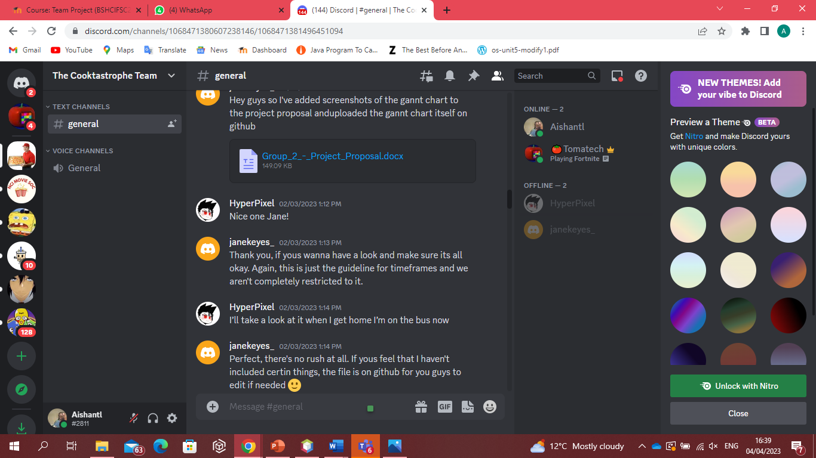

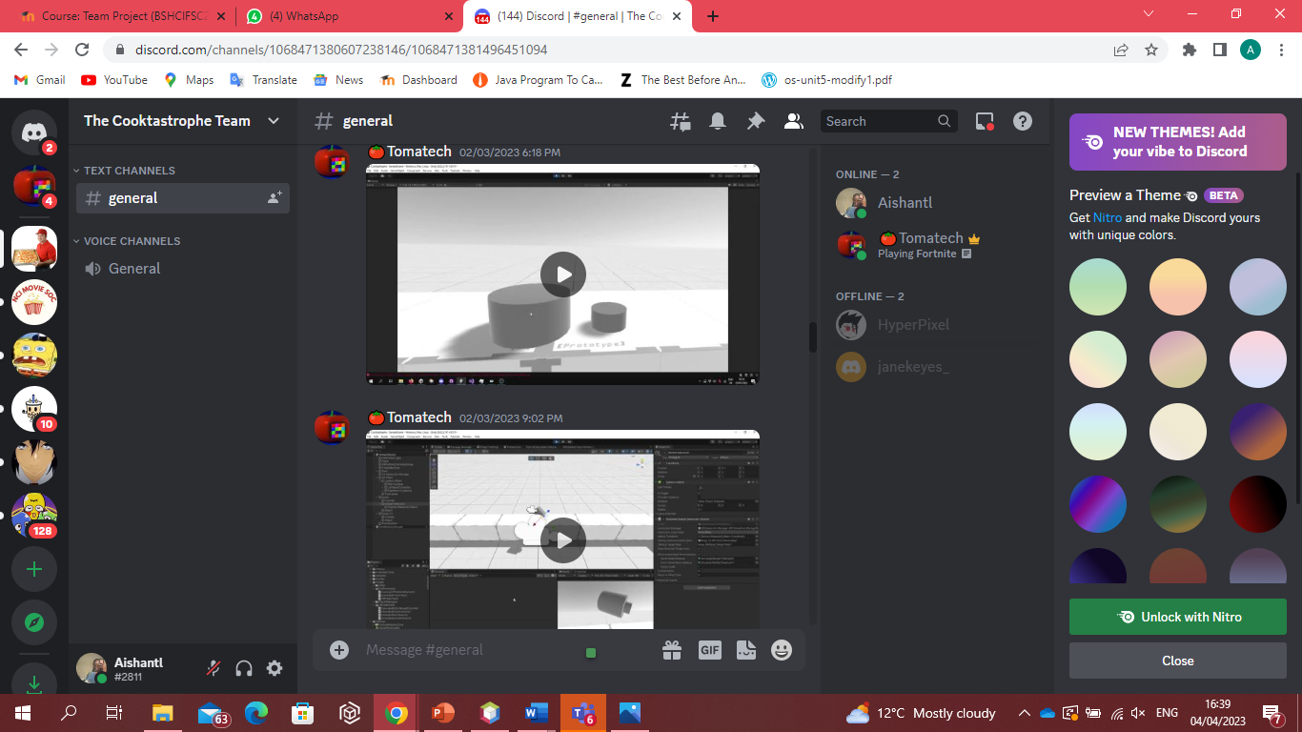

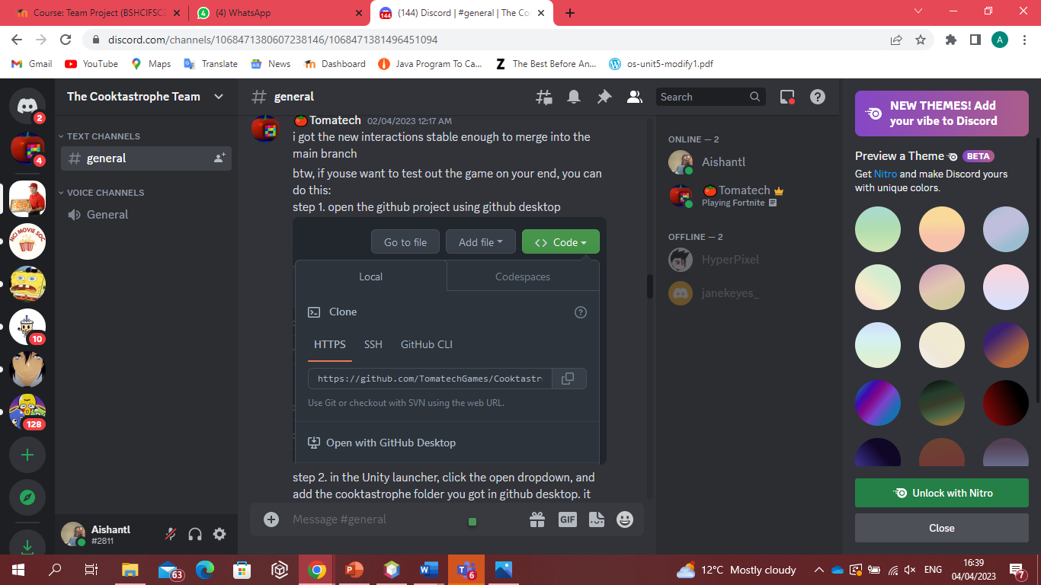

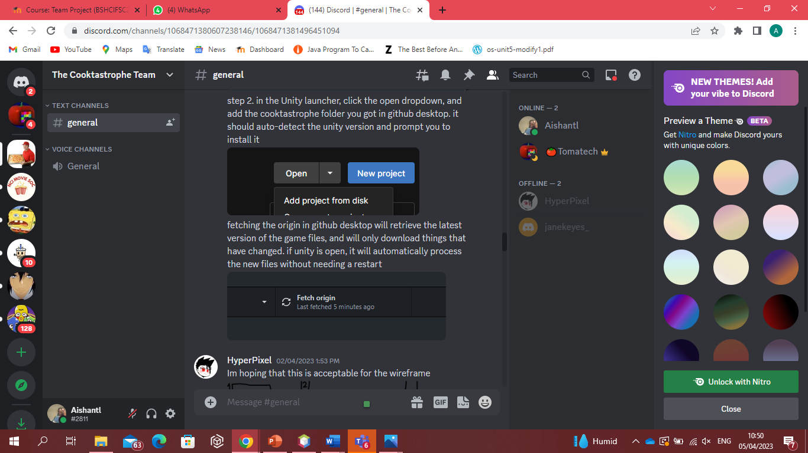

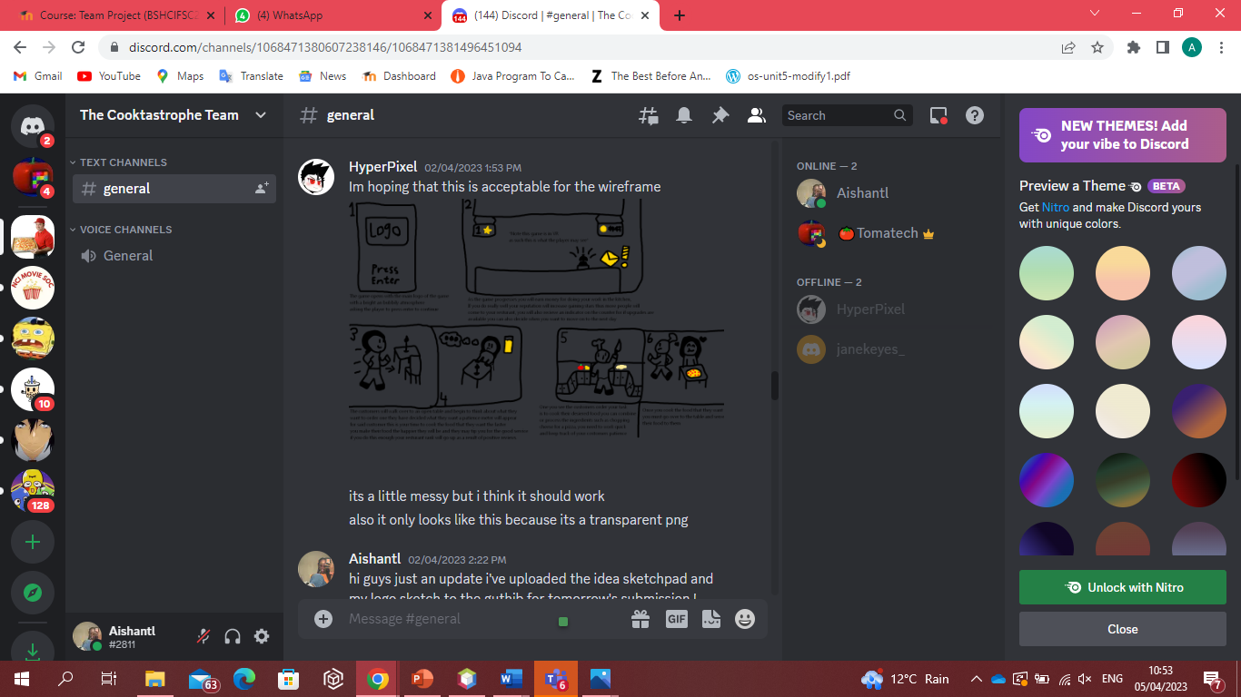

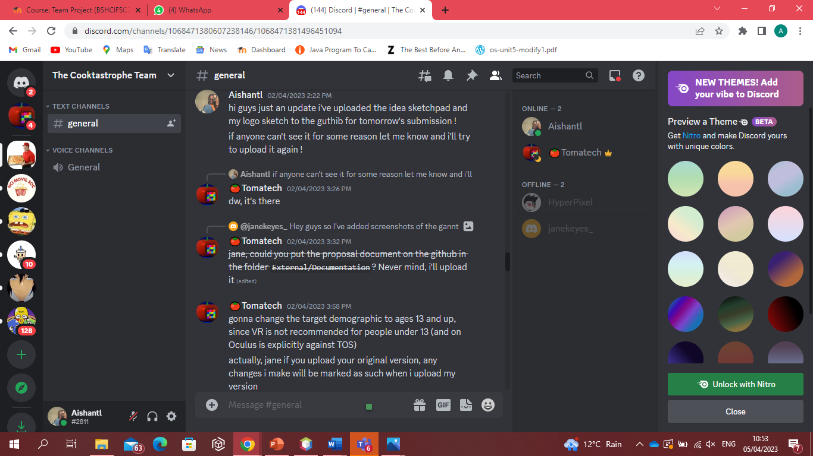

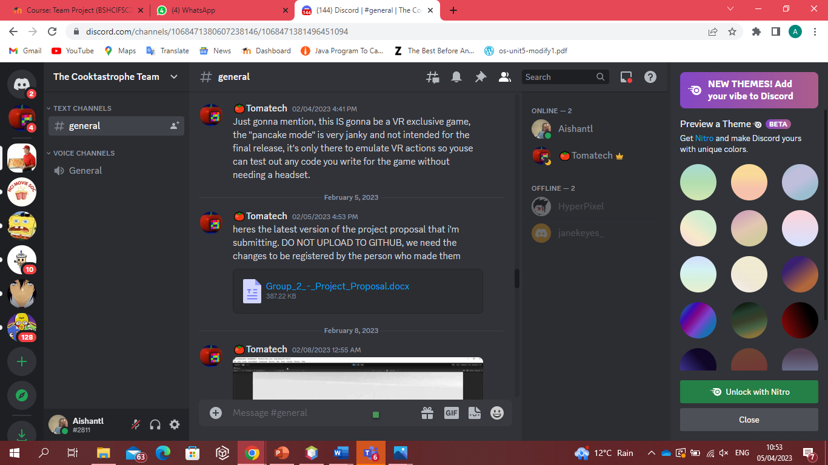

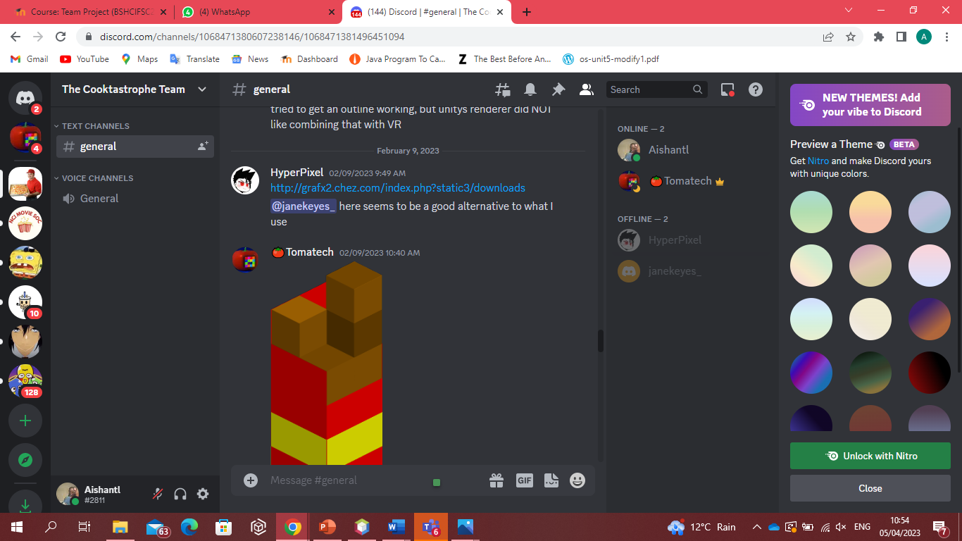

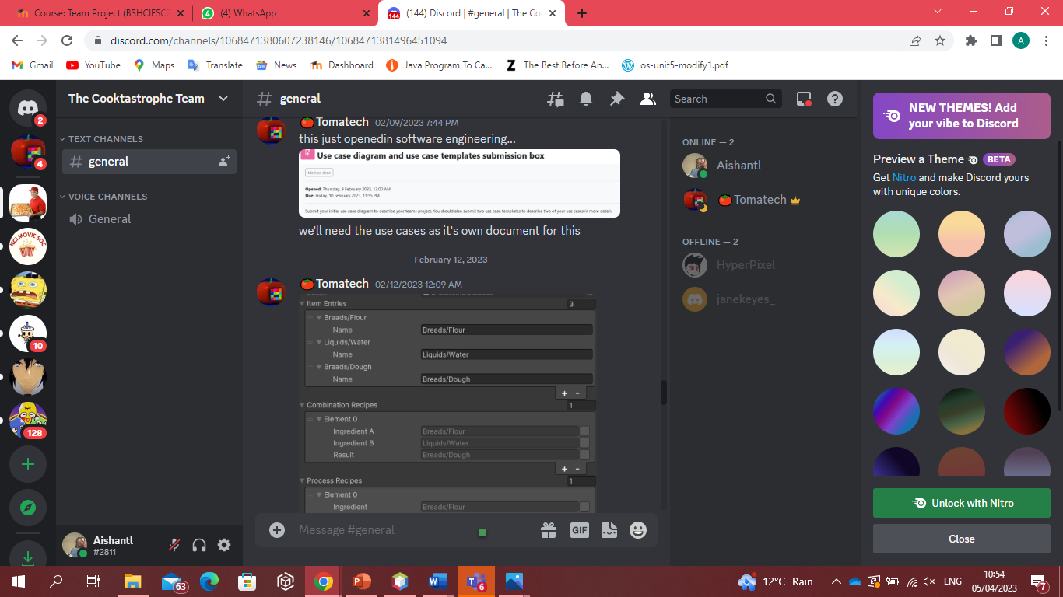

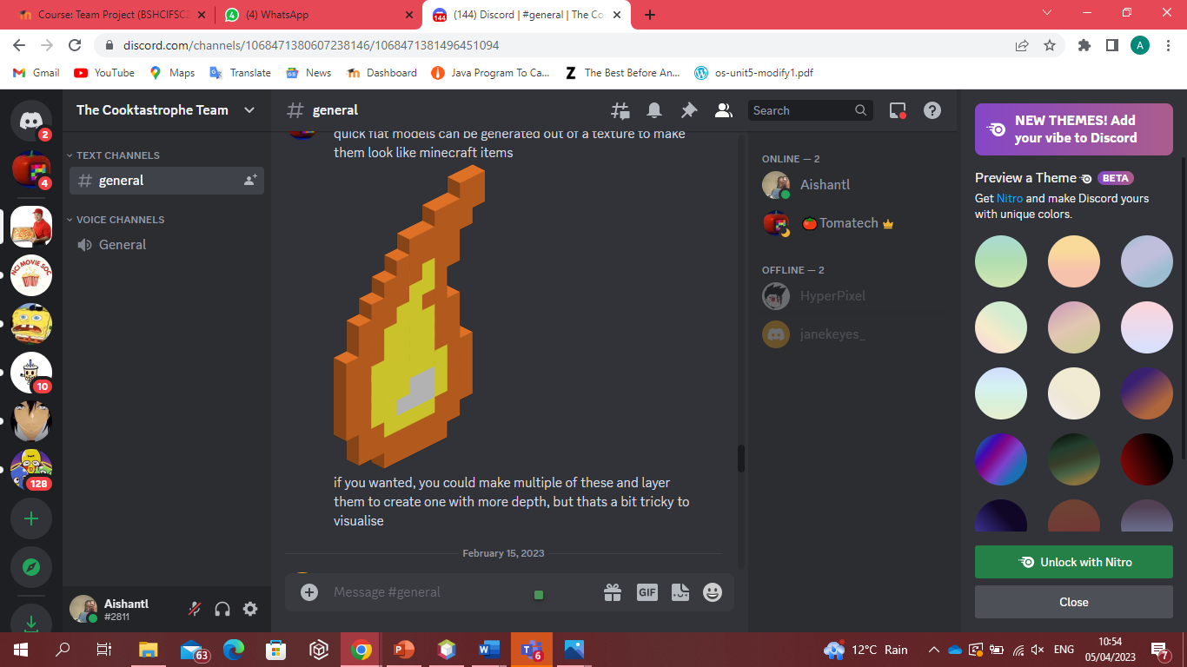

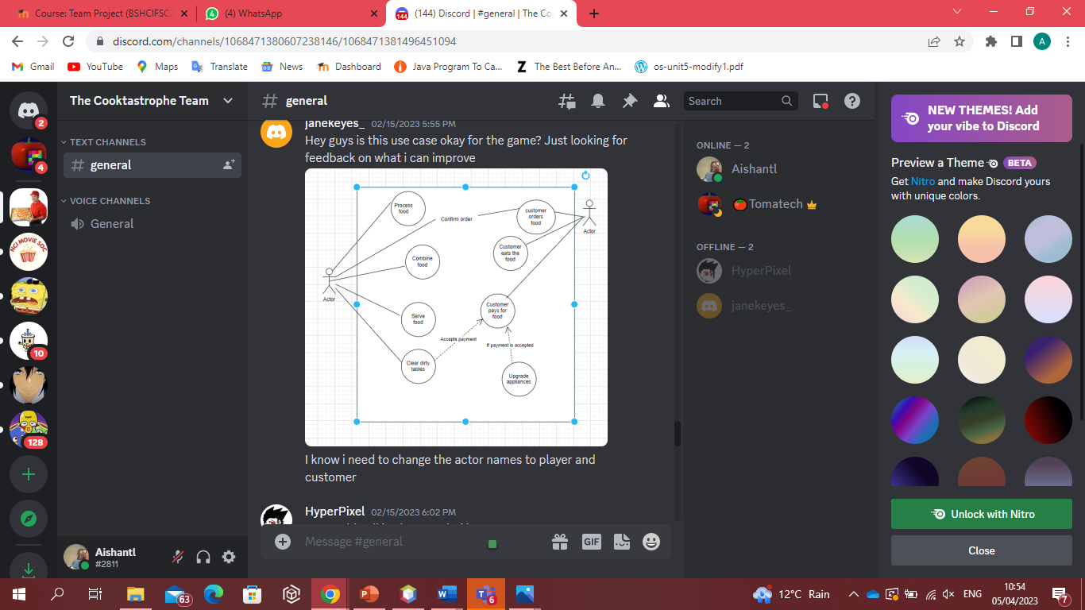

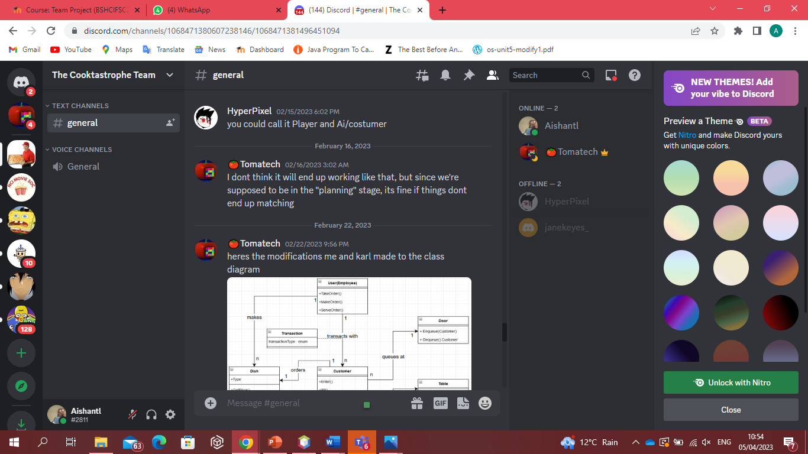

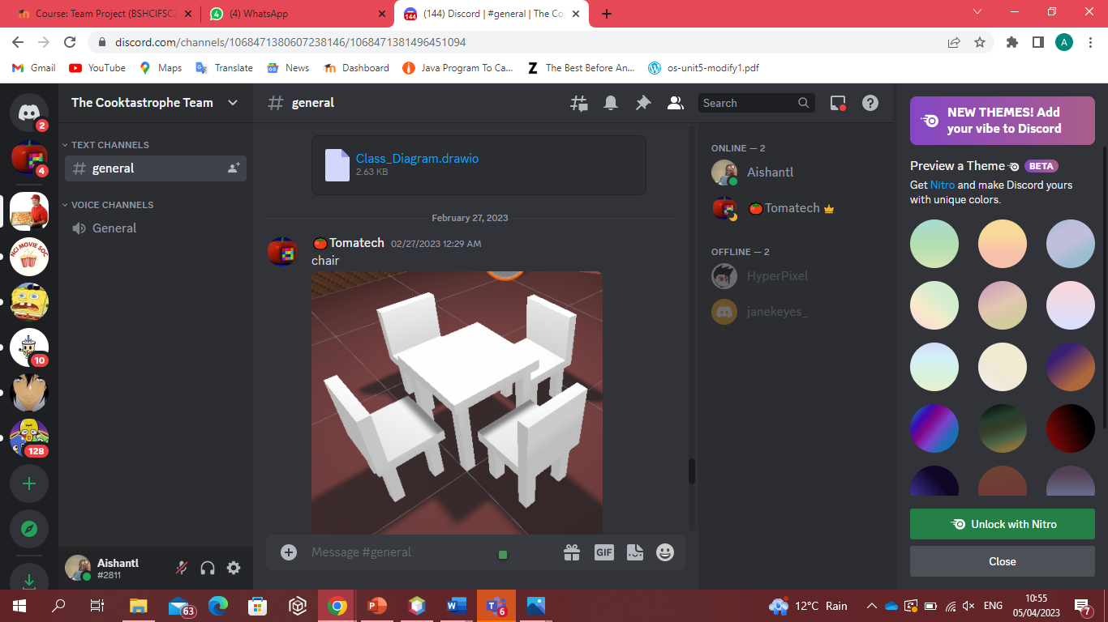

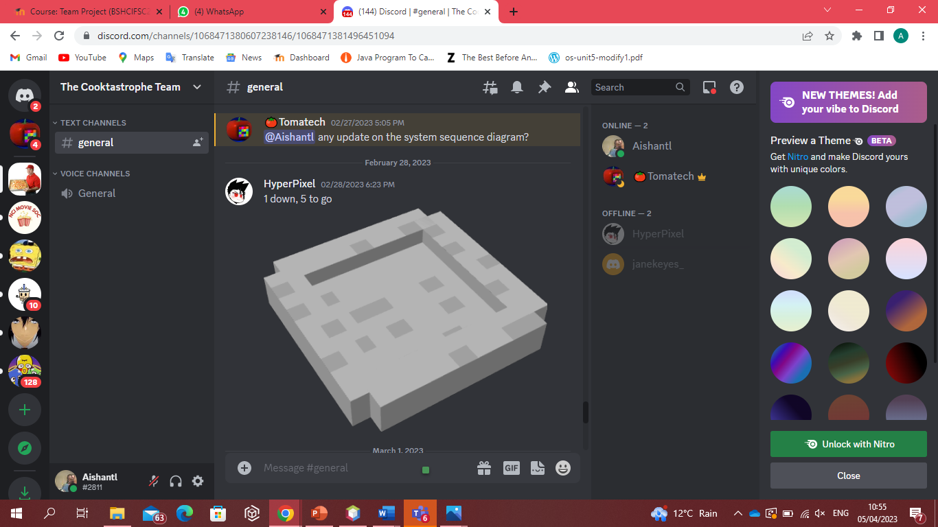

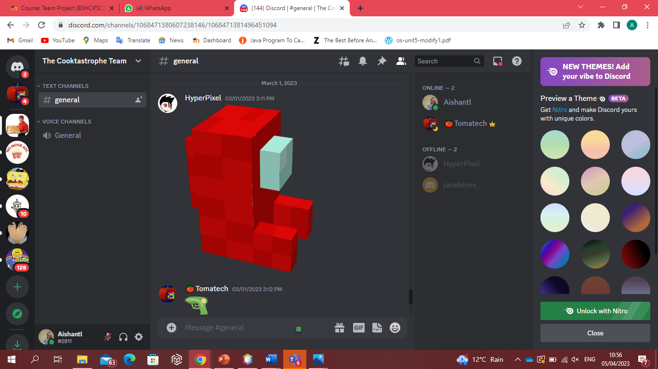

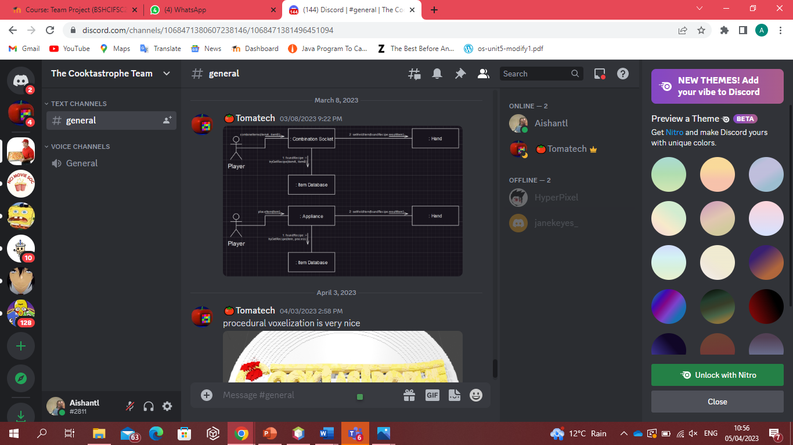

The above are screenshots from our shared discord server we did not use this as our main form of communication but it’s definitely worth noting and adding to our appendices as it shows our continued collaboration.

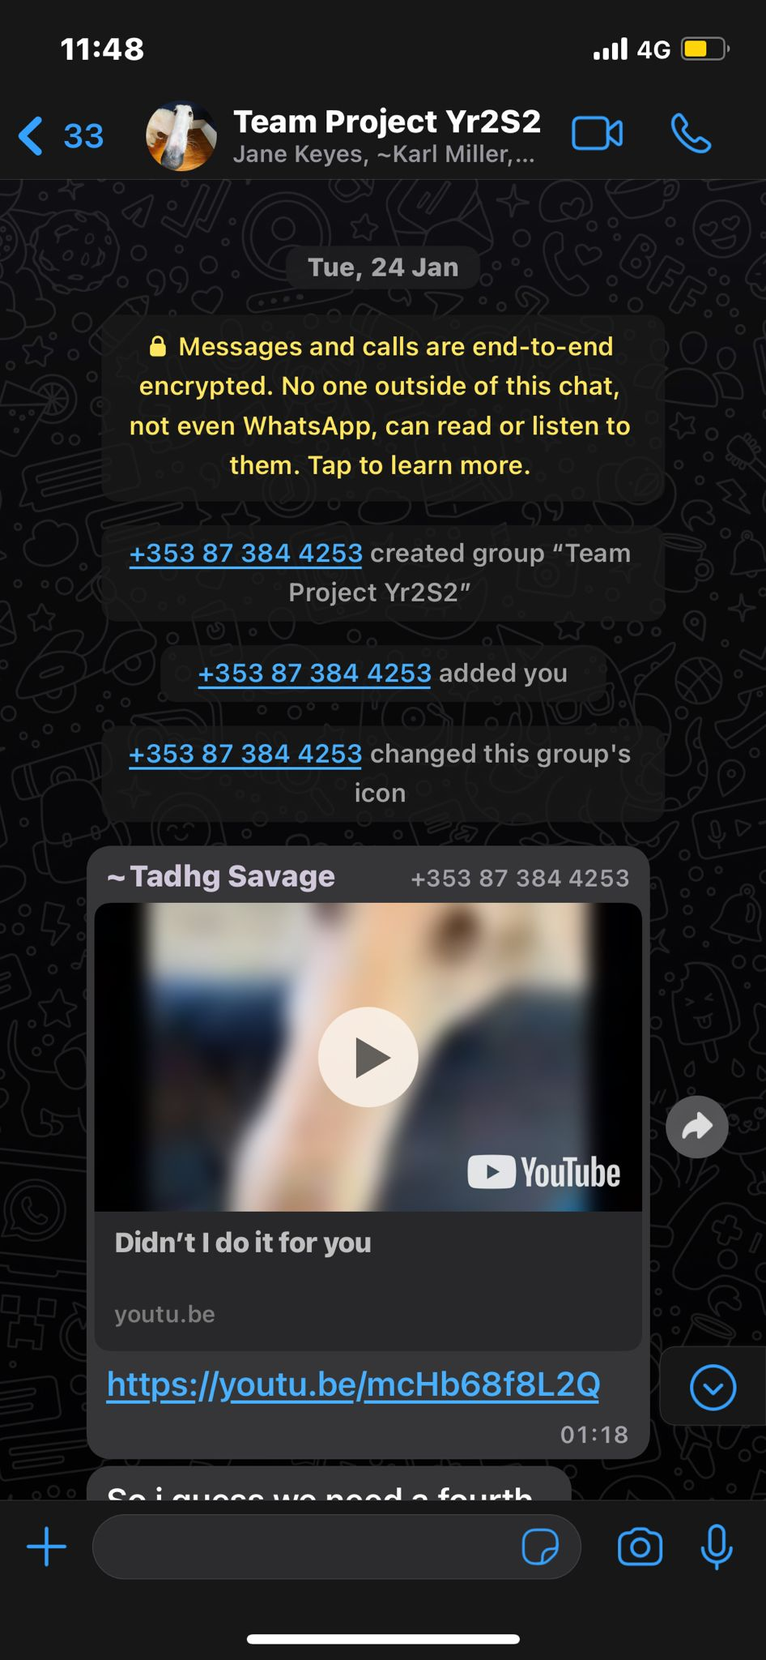

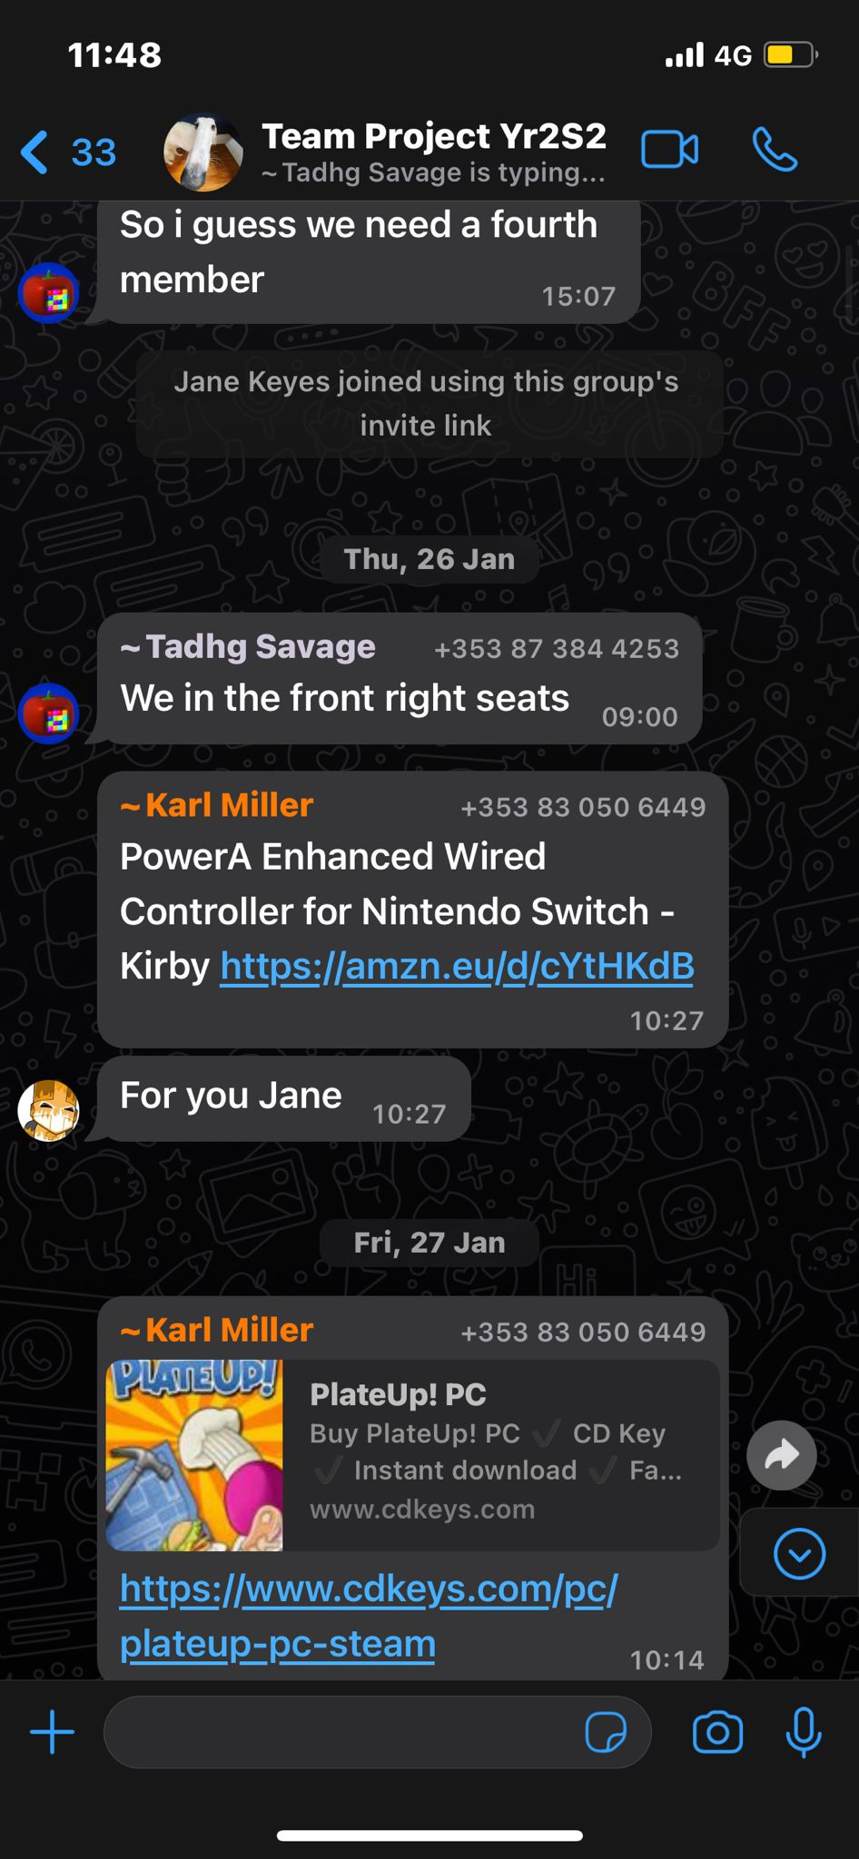

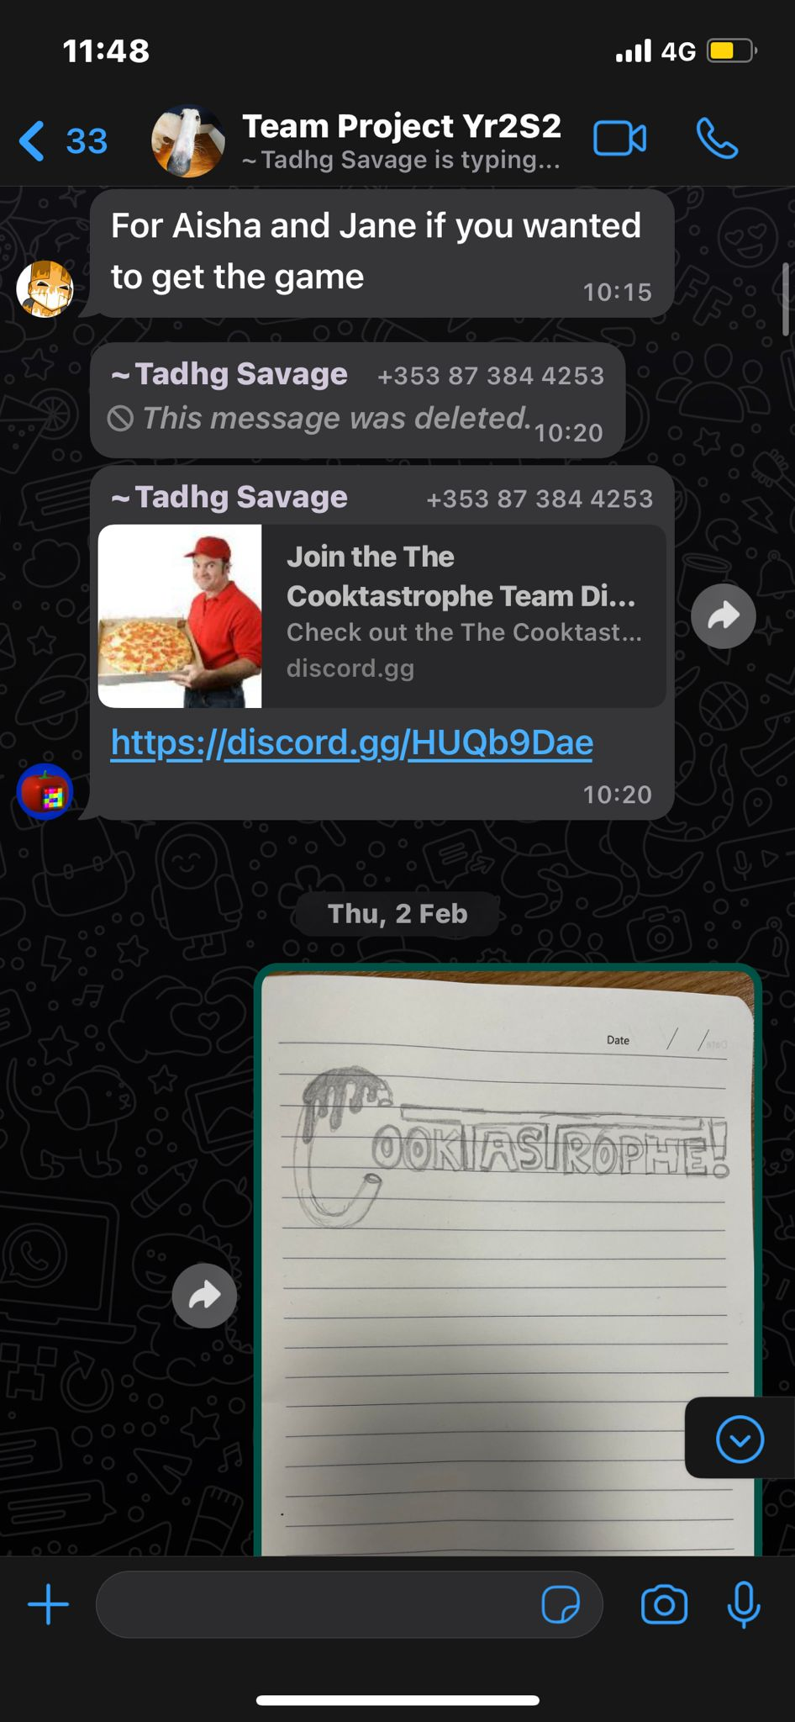

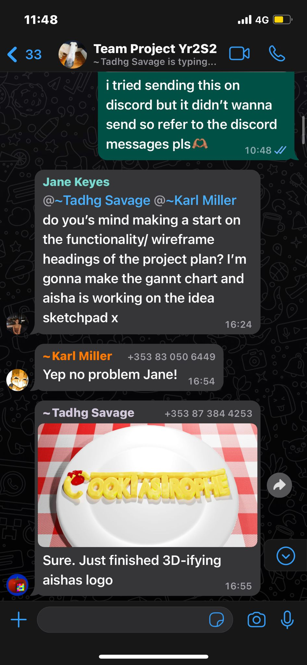

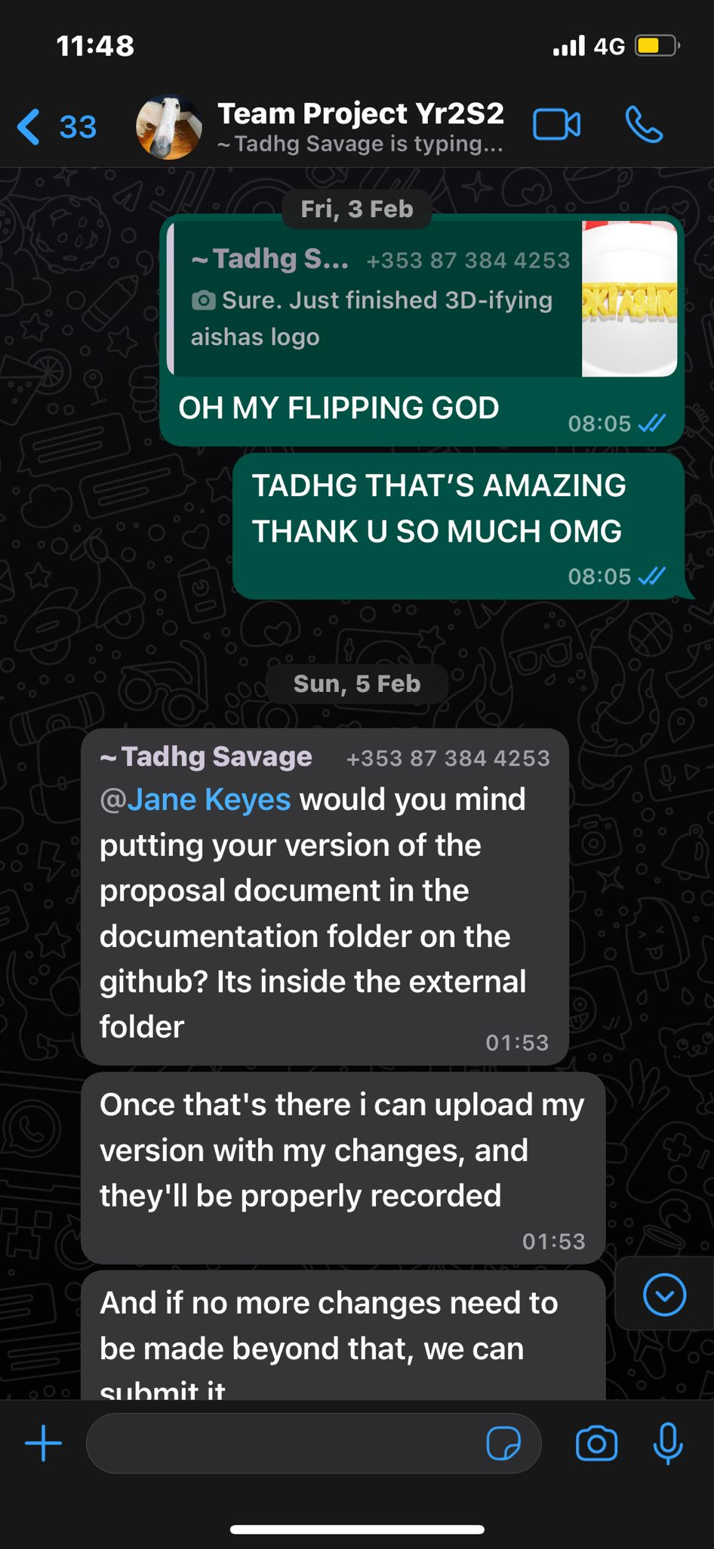

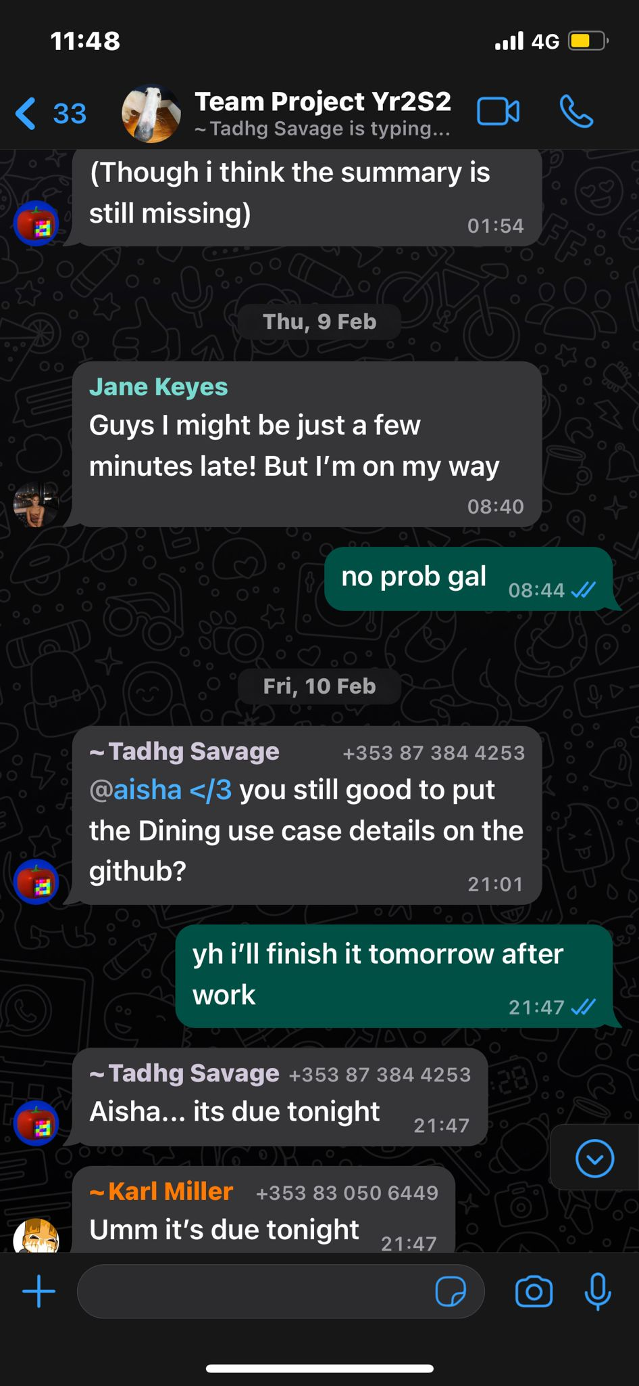

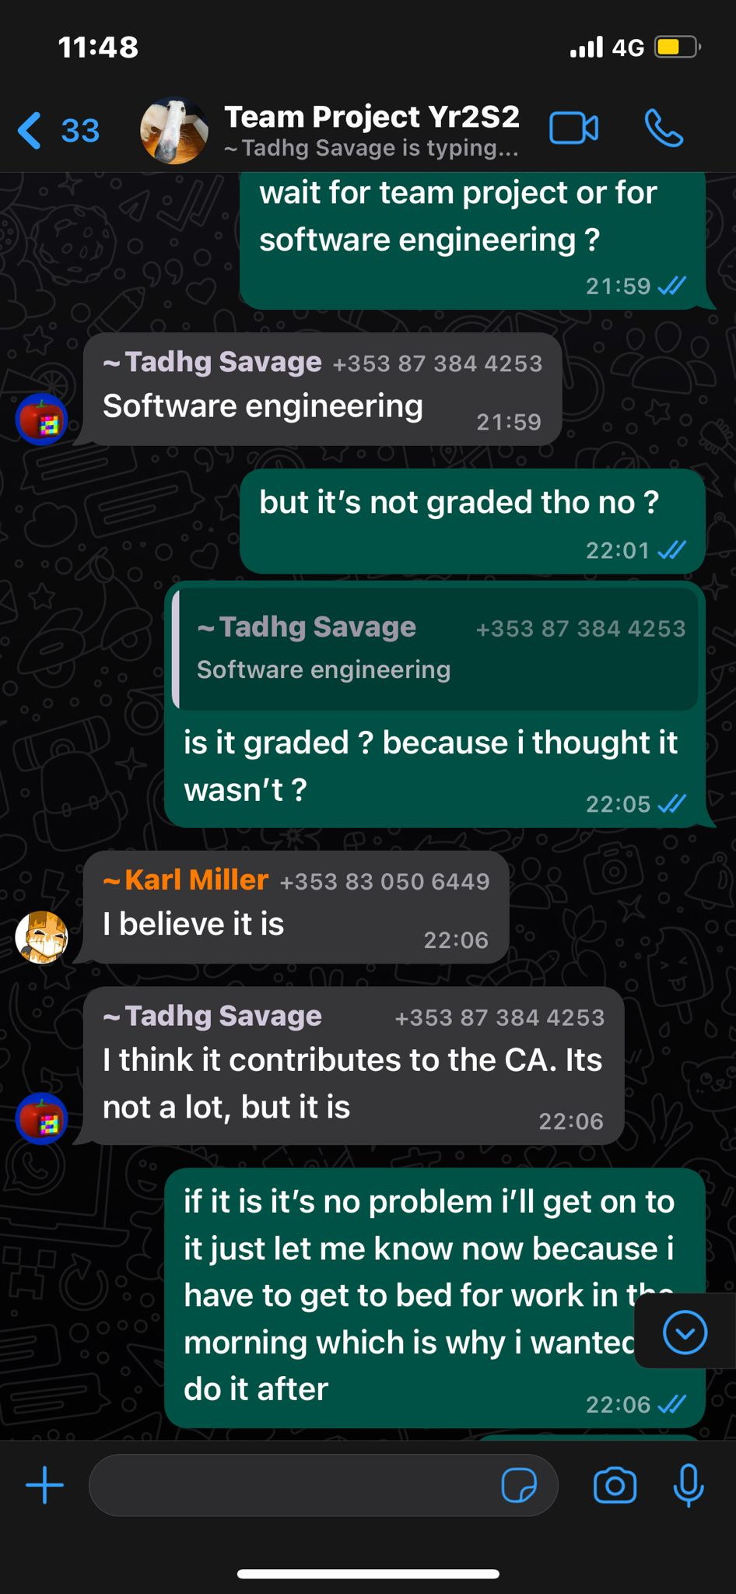

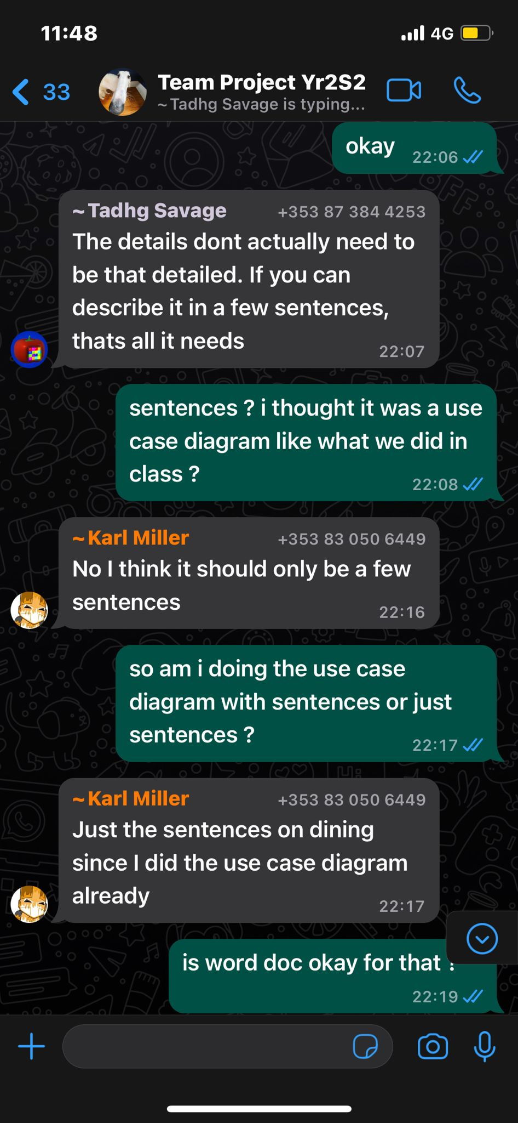

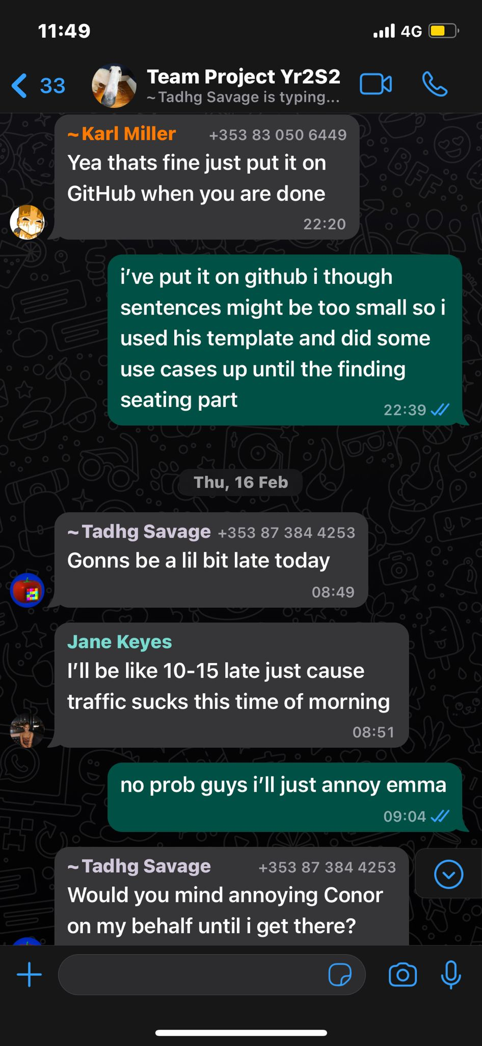

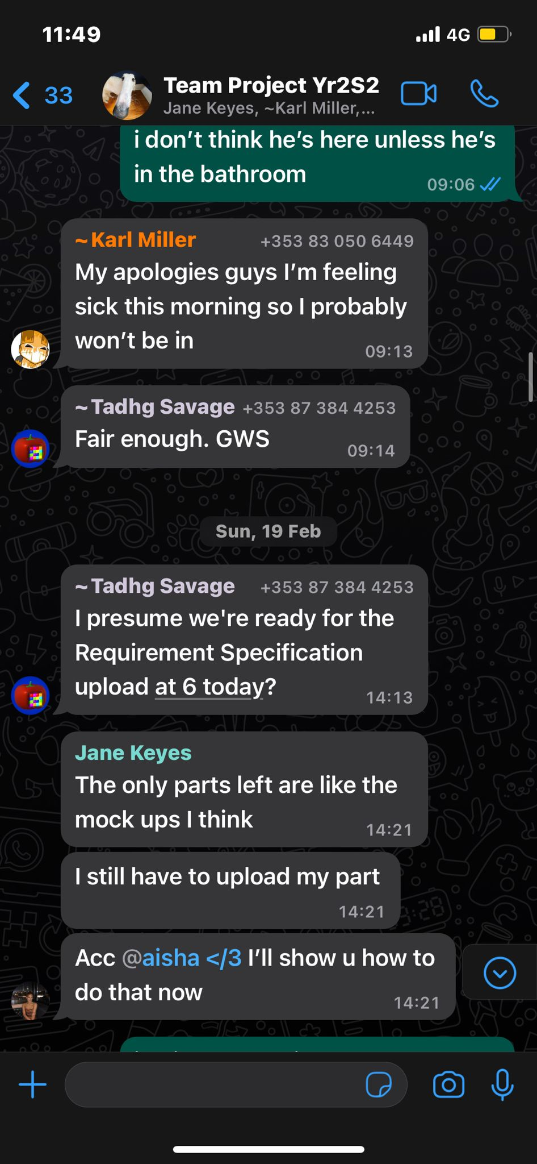

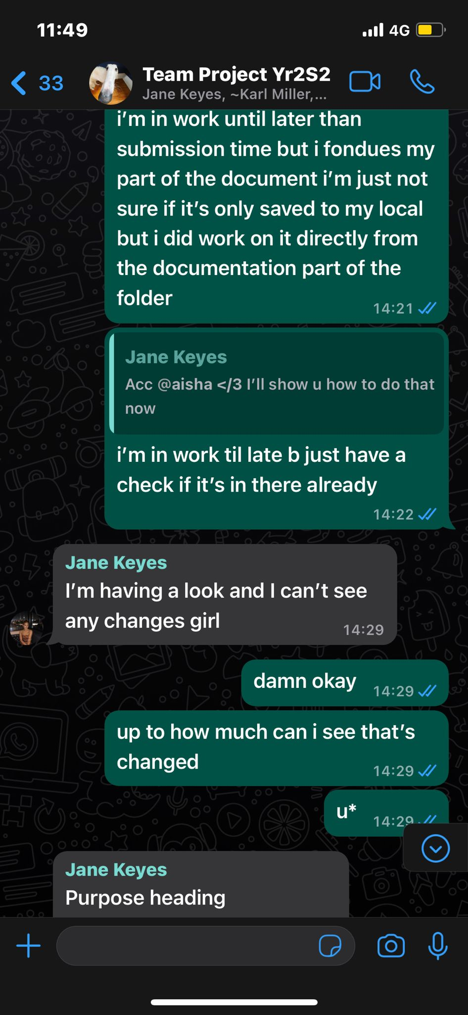

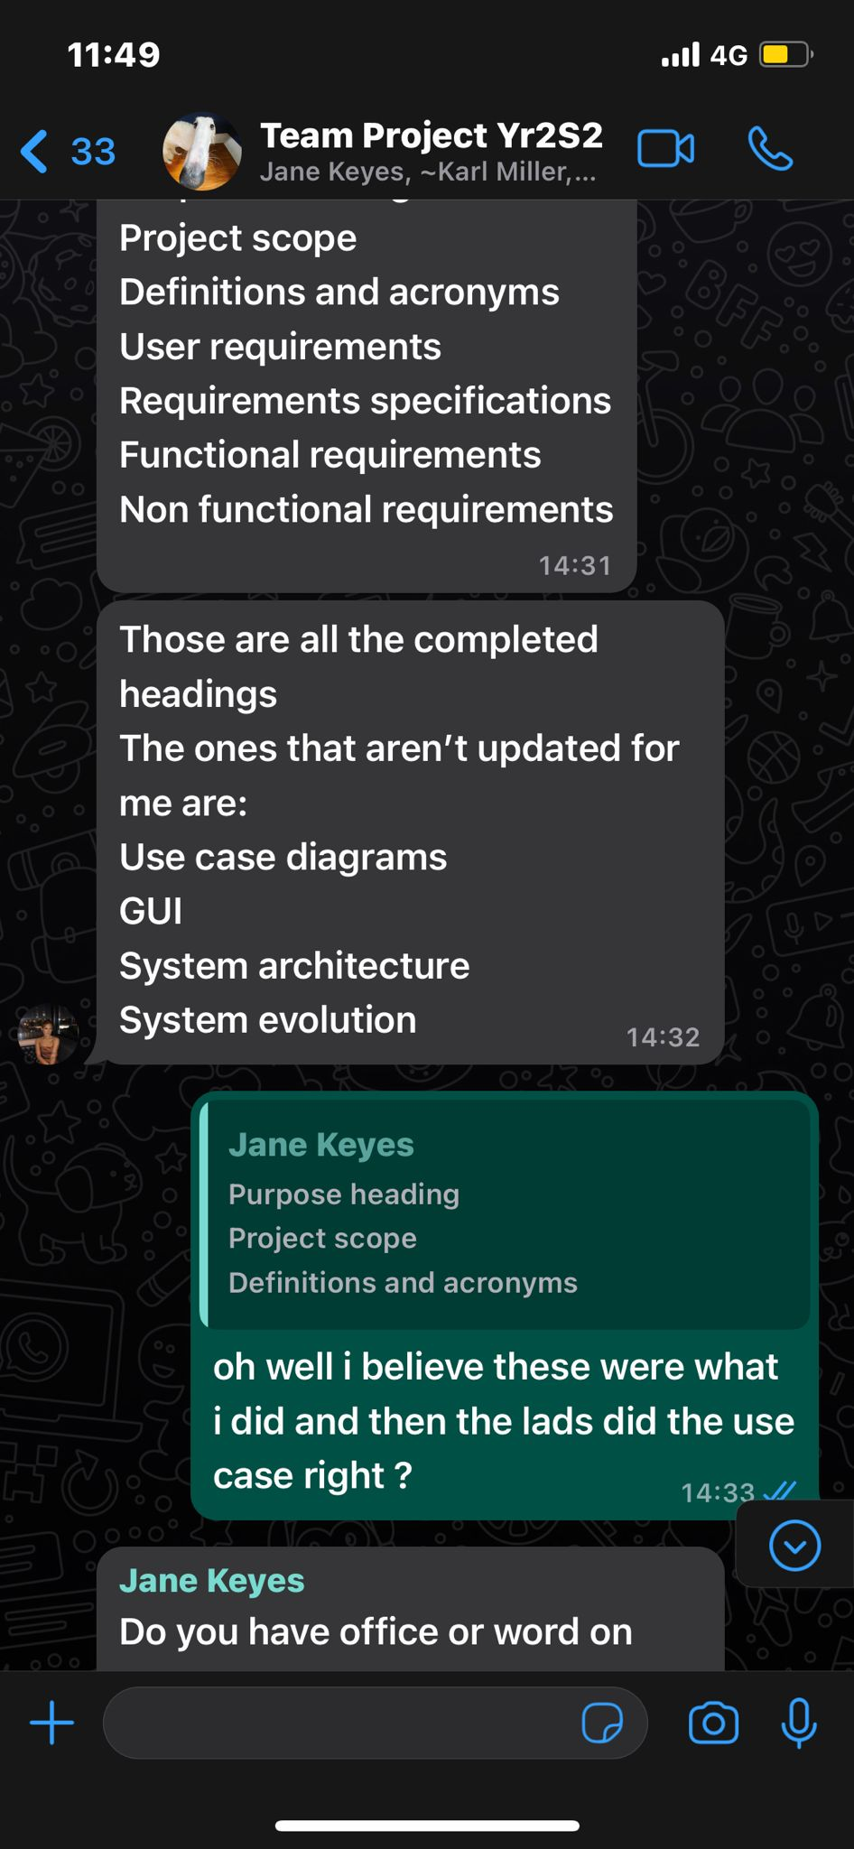

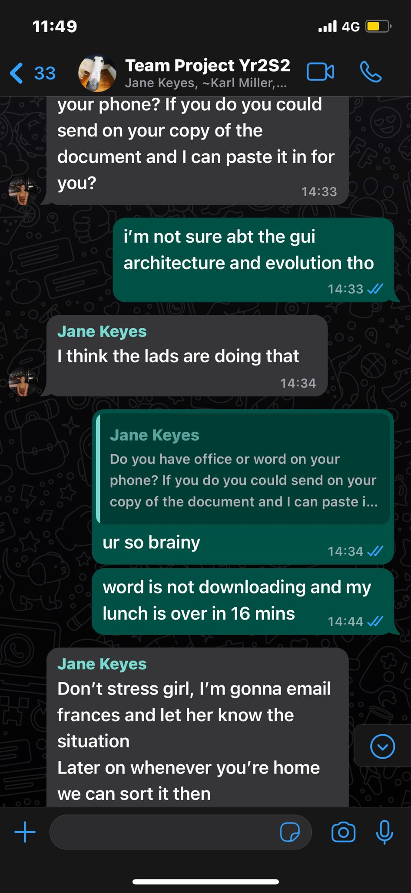

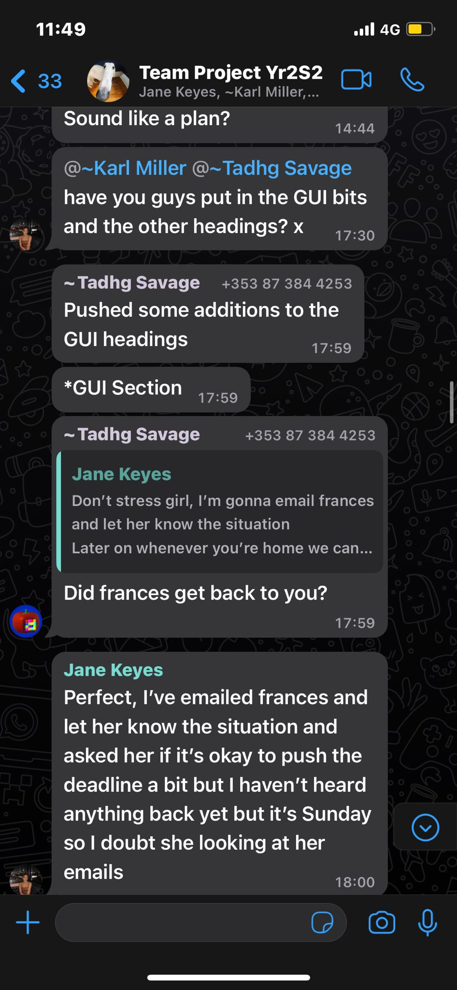

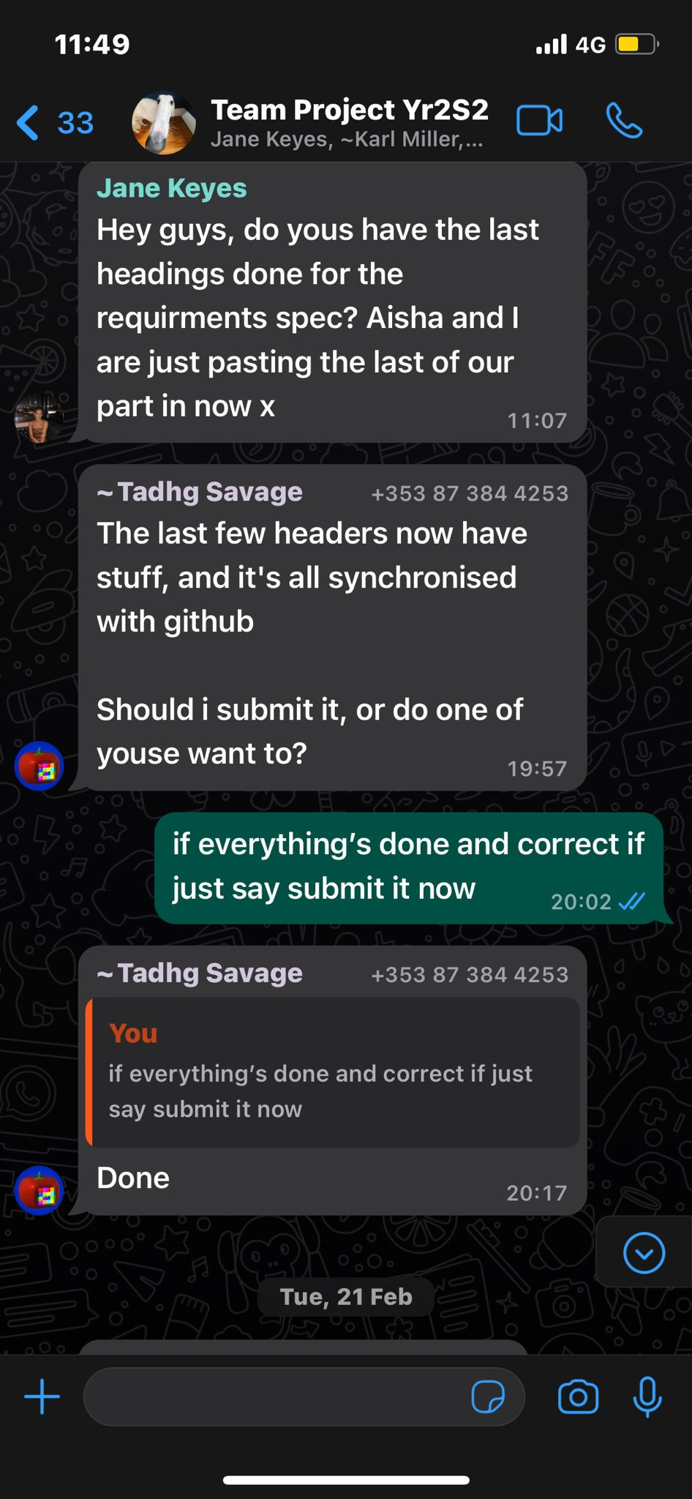

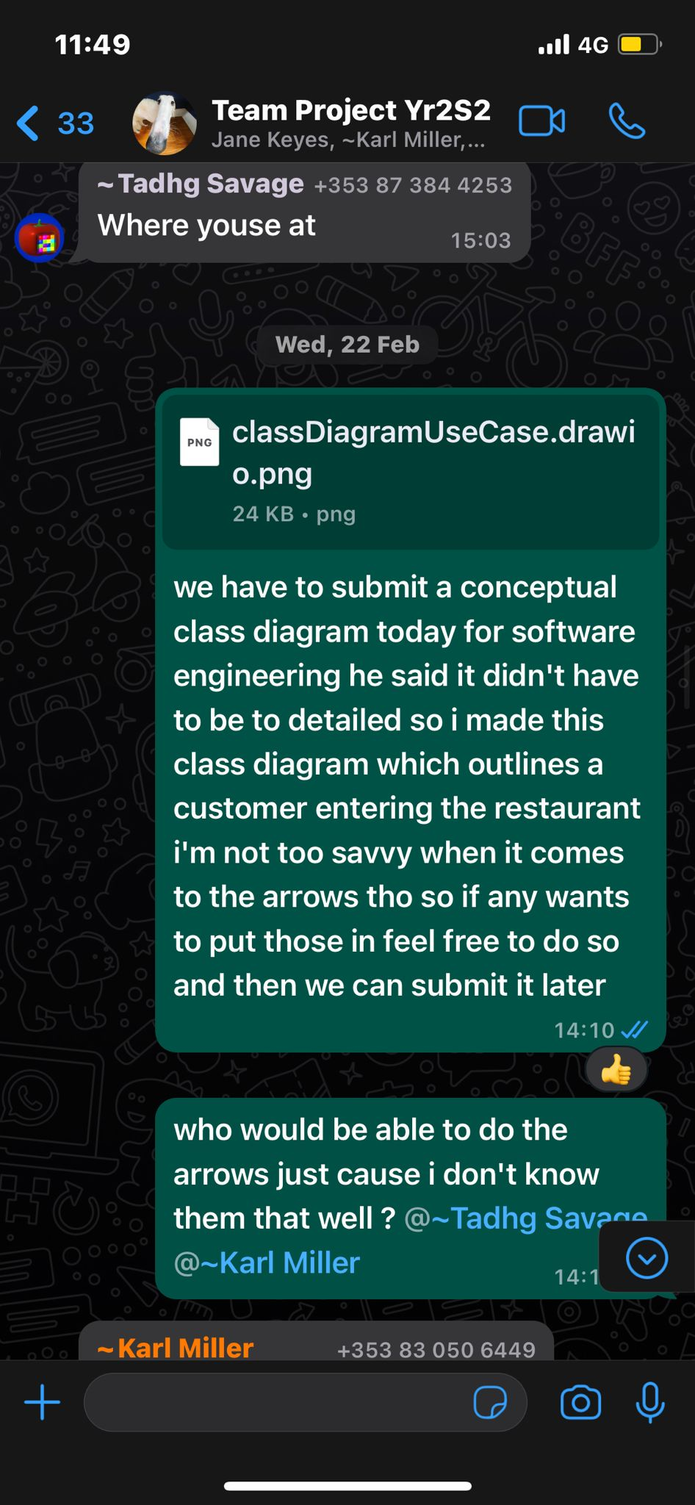

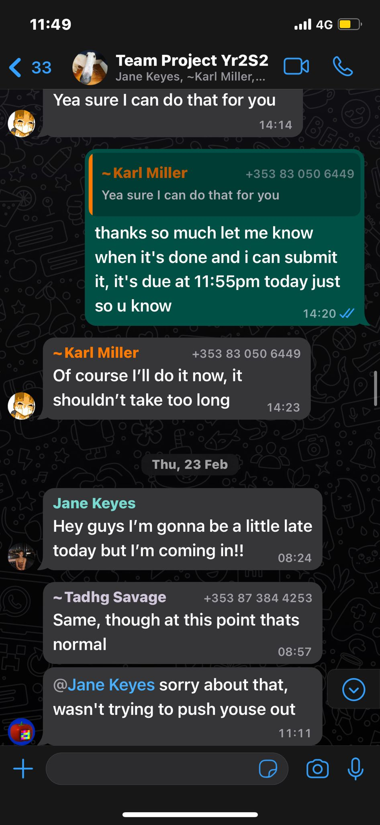

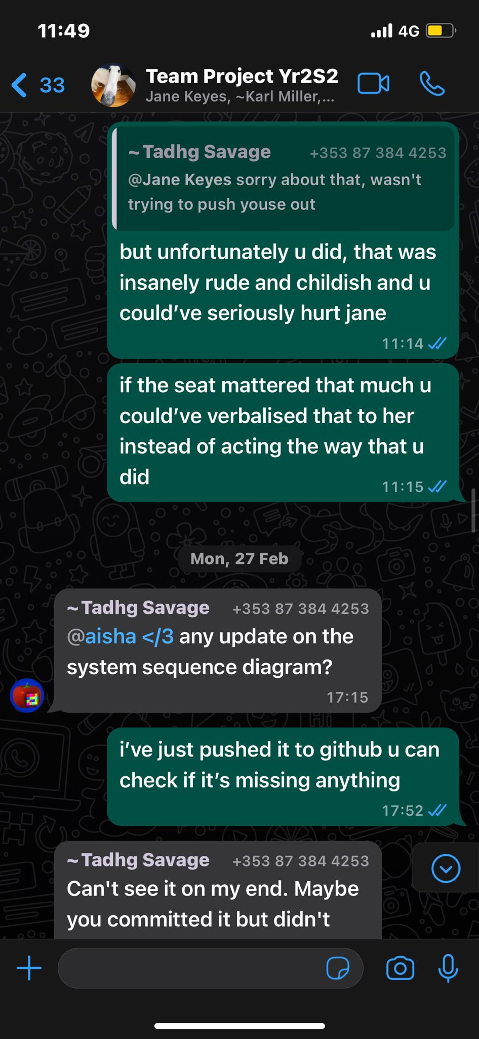

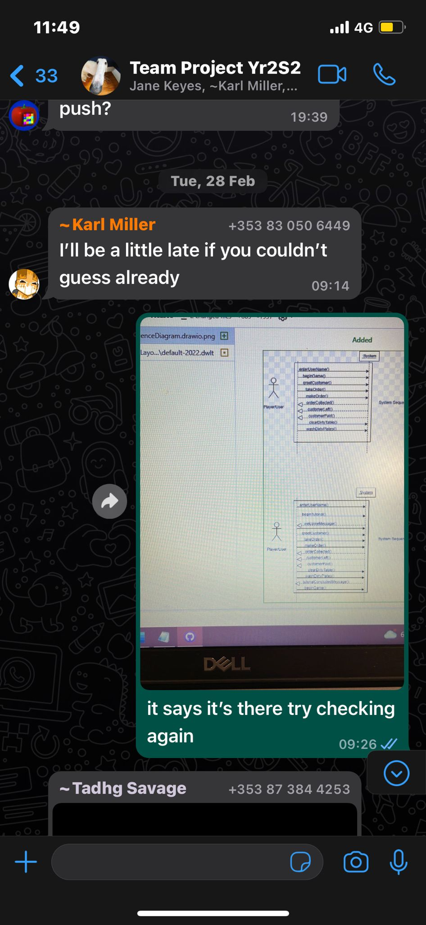

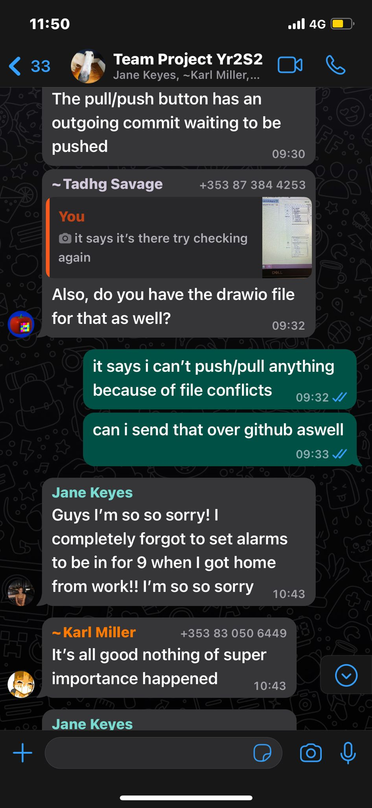

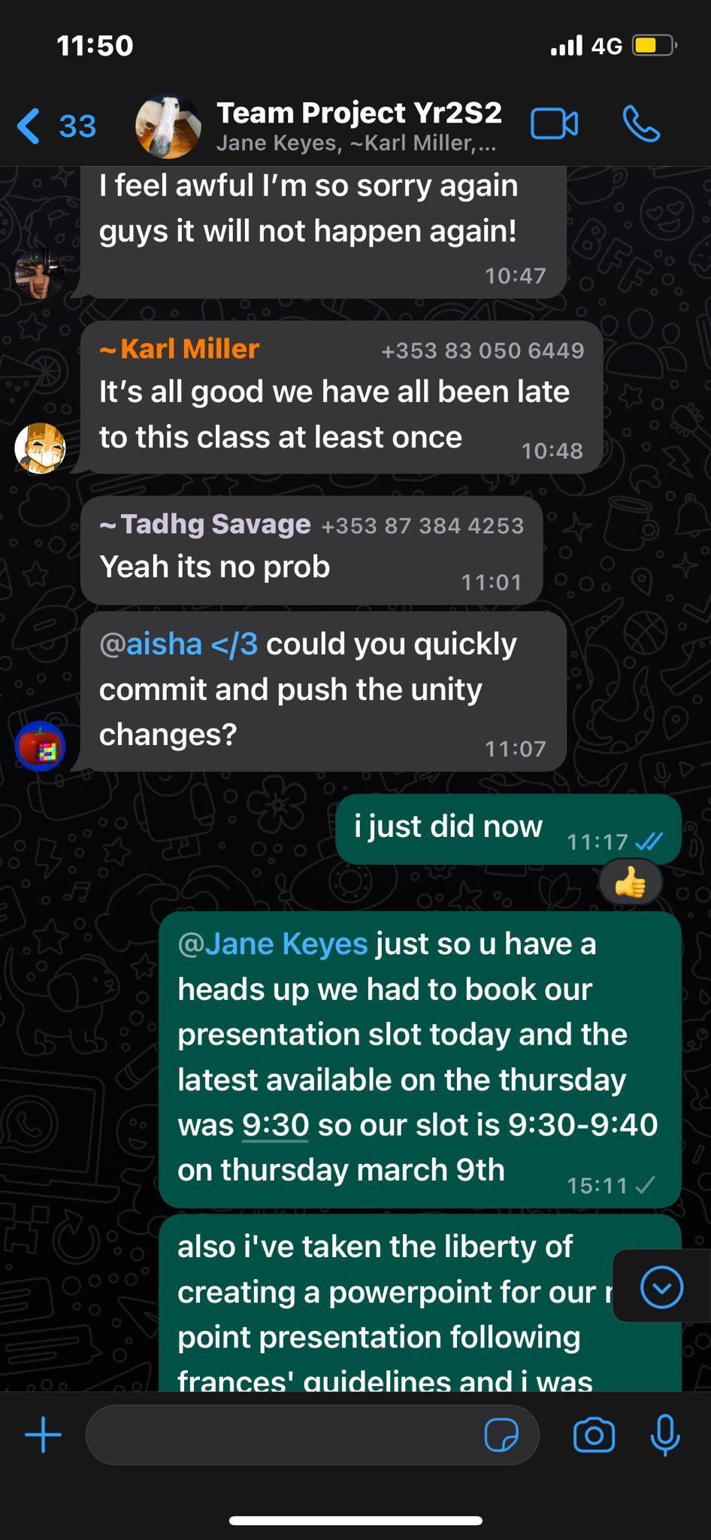

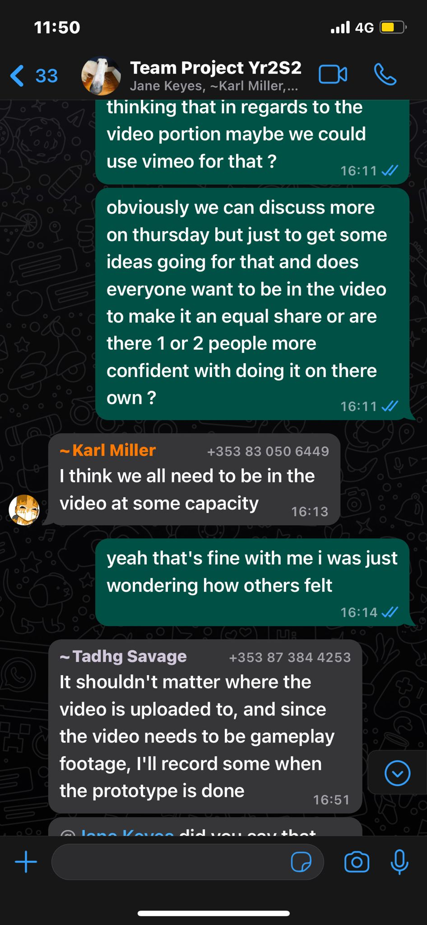



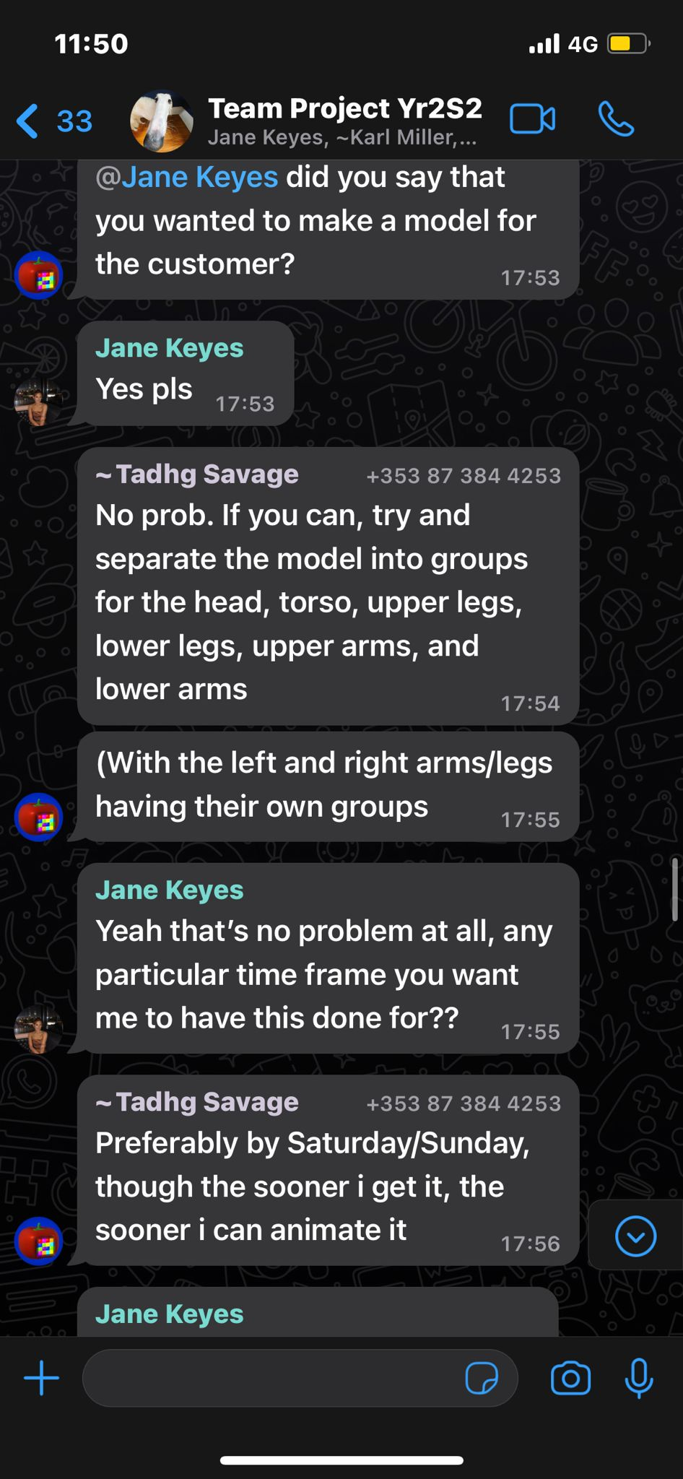

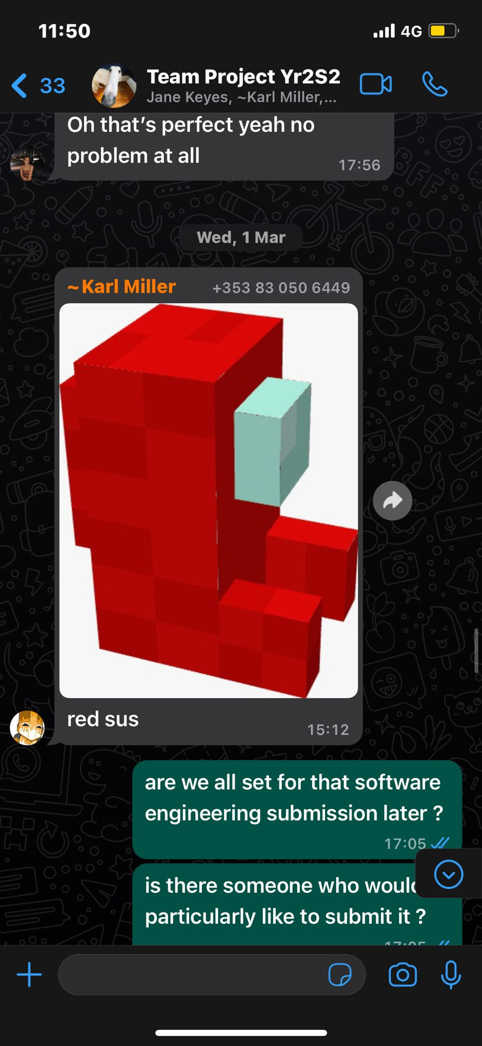

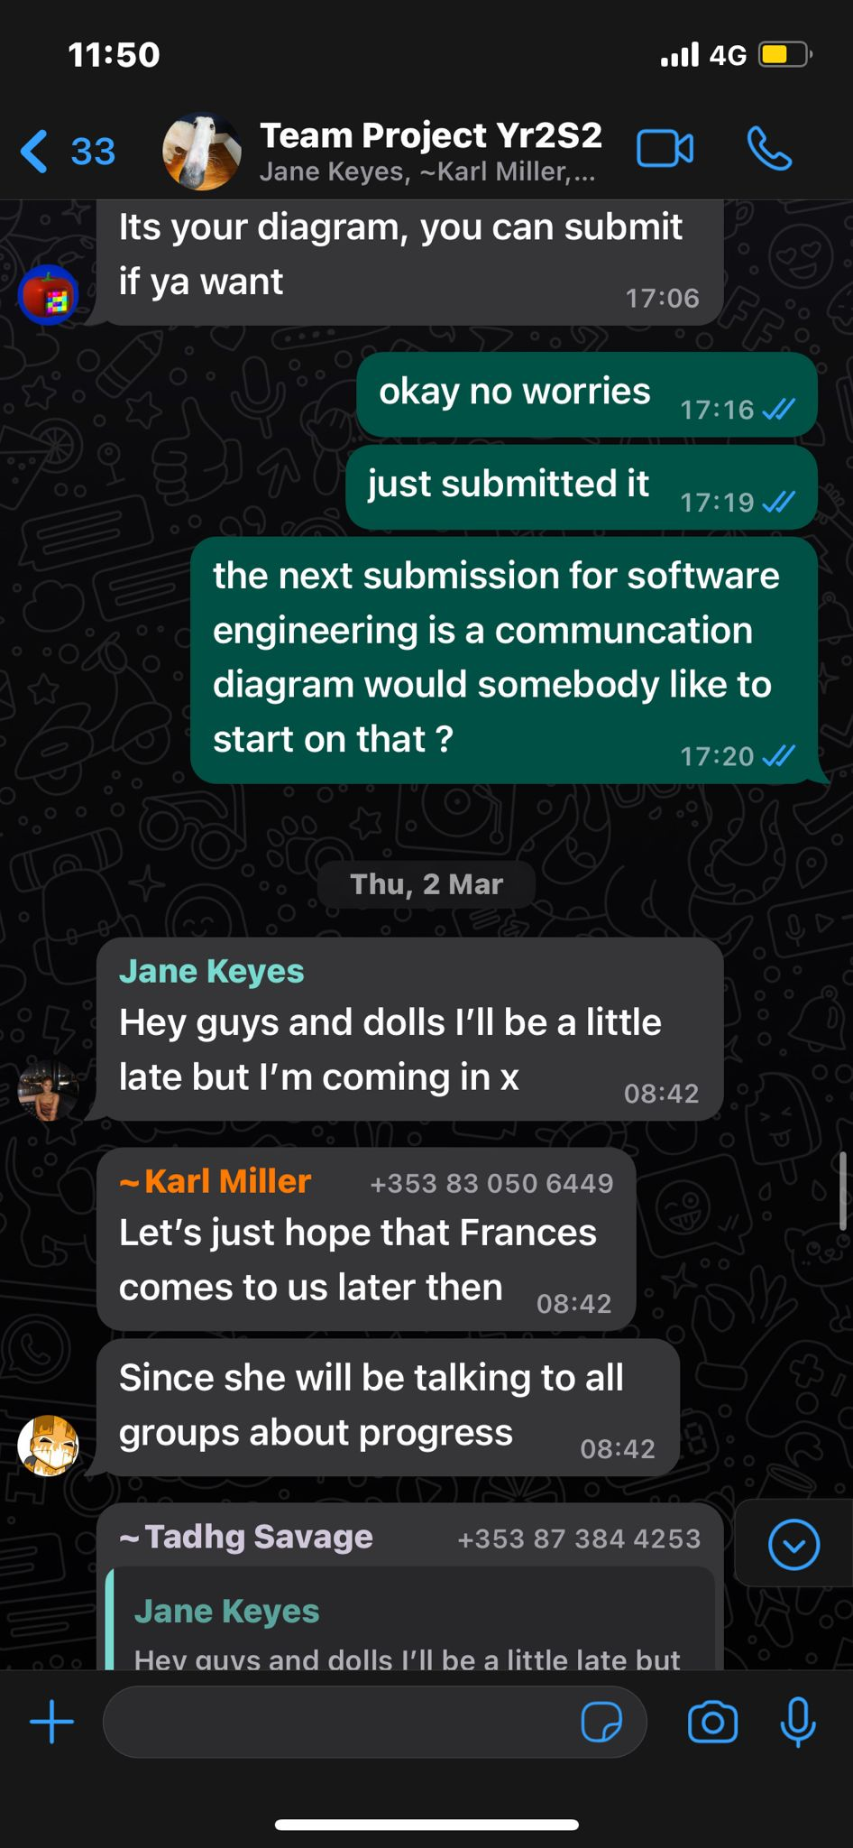



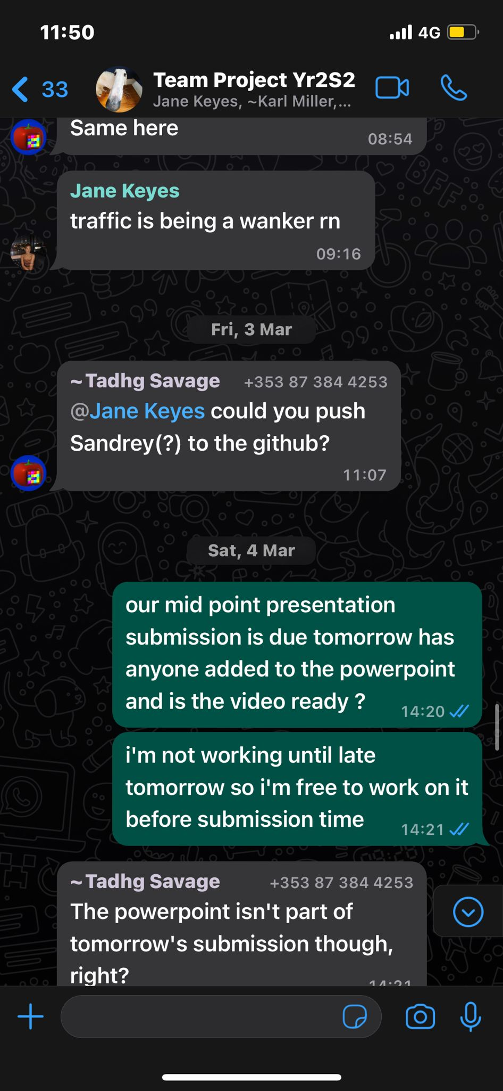

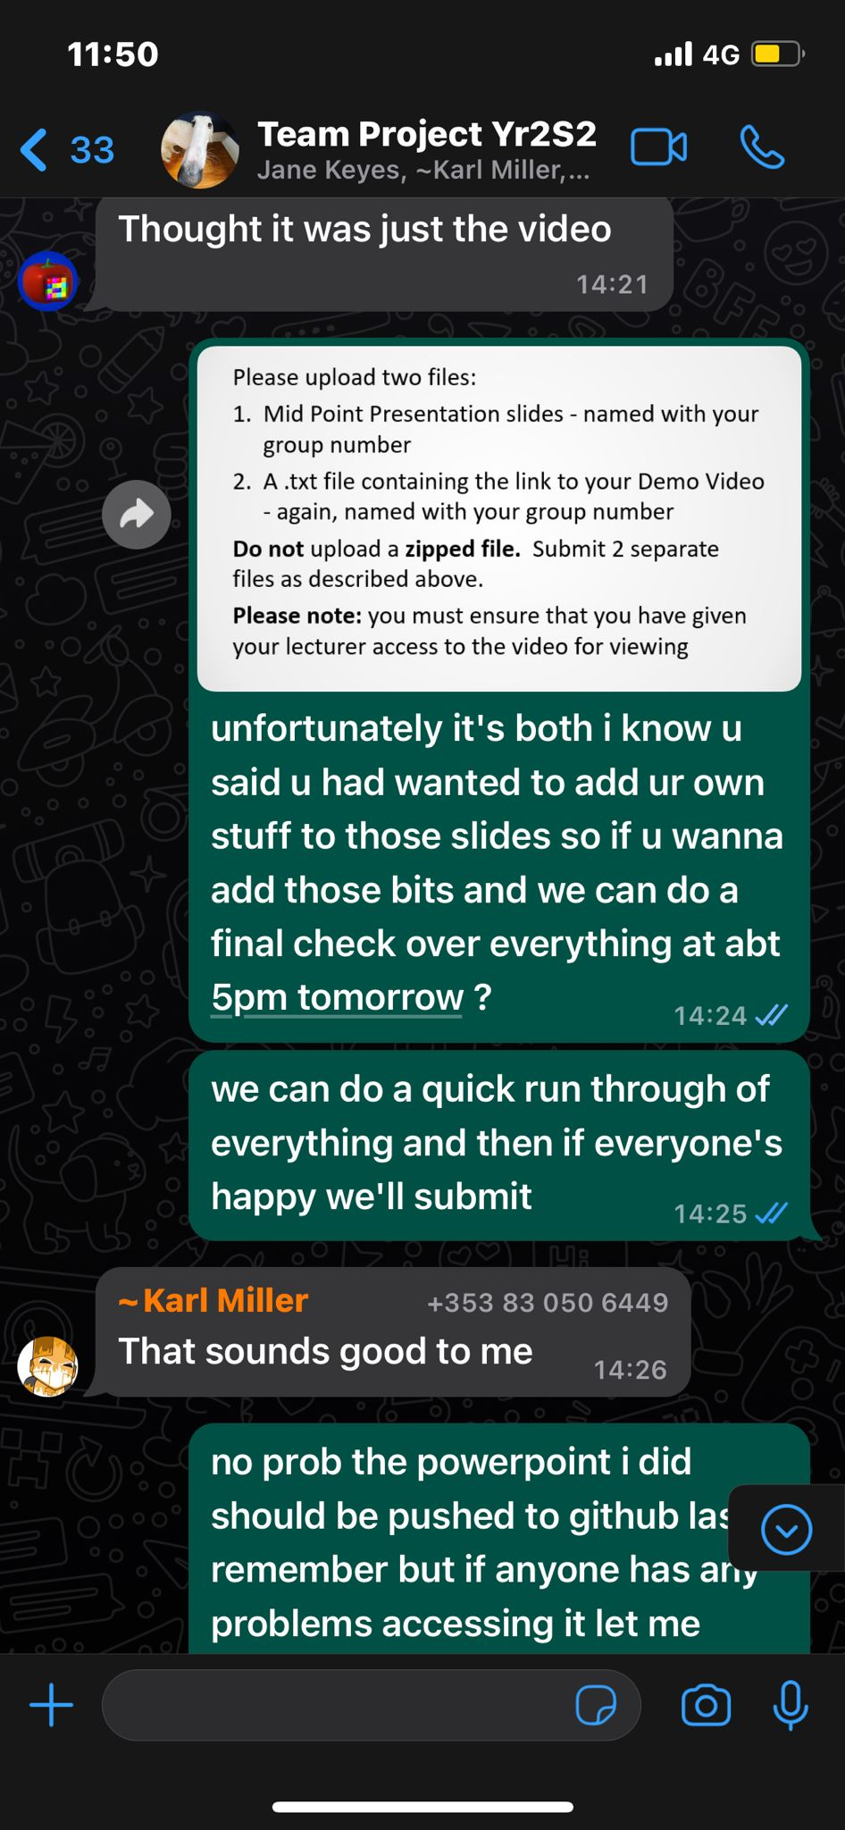

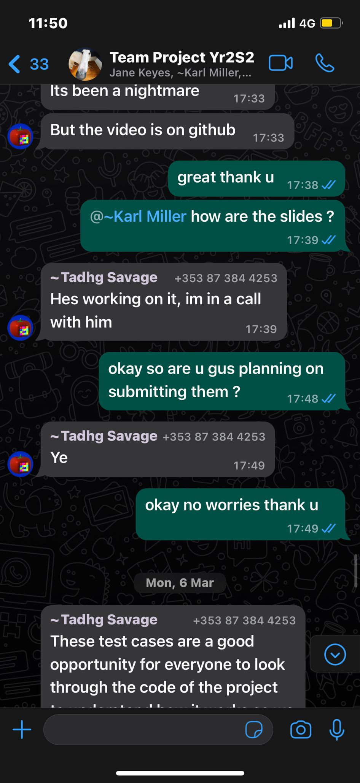

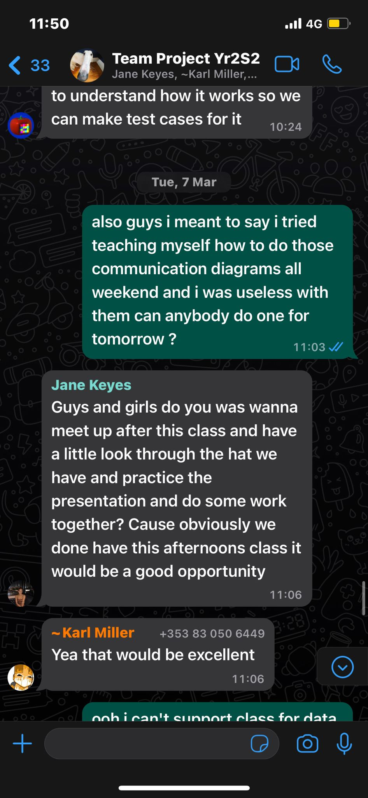



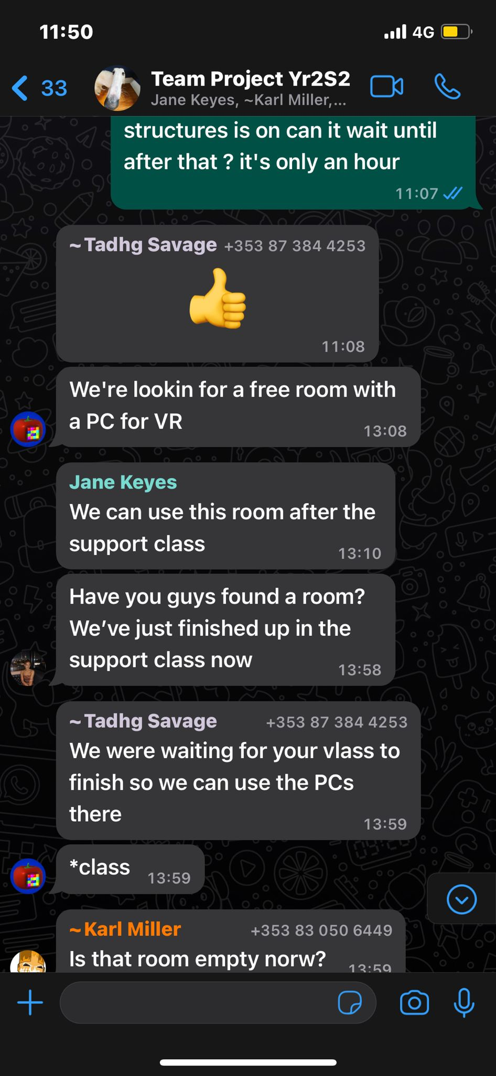

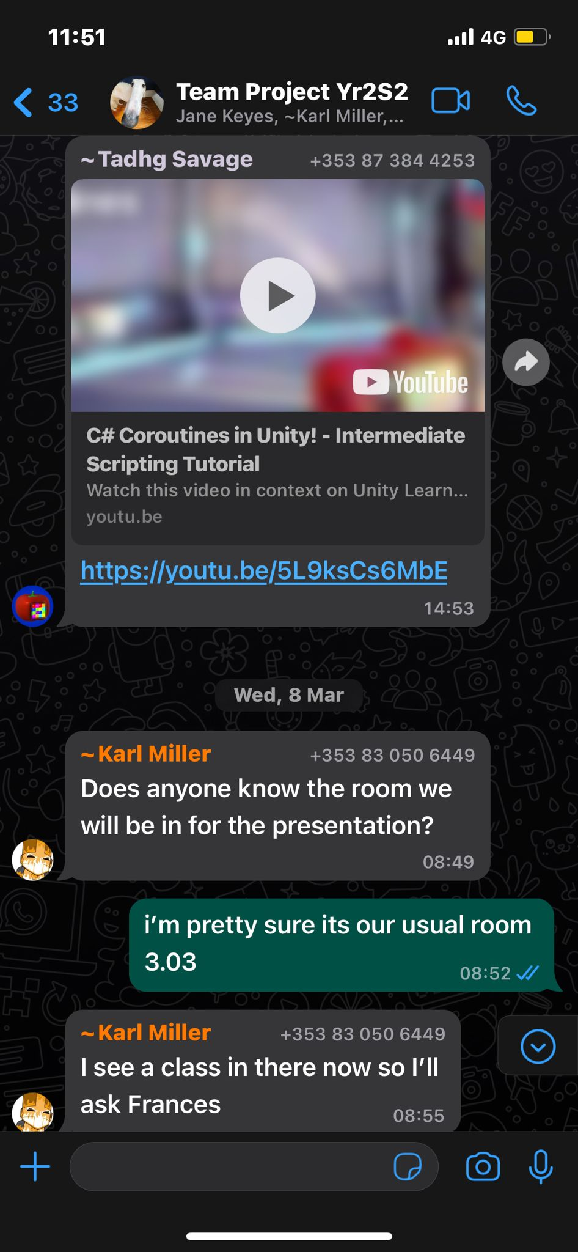

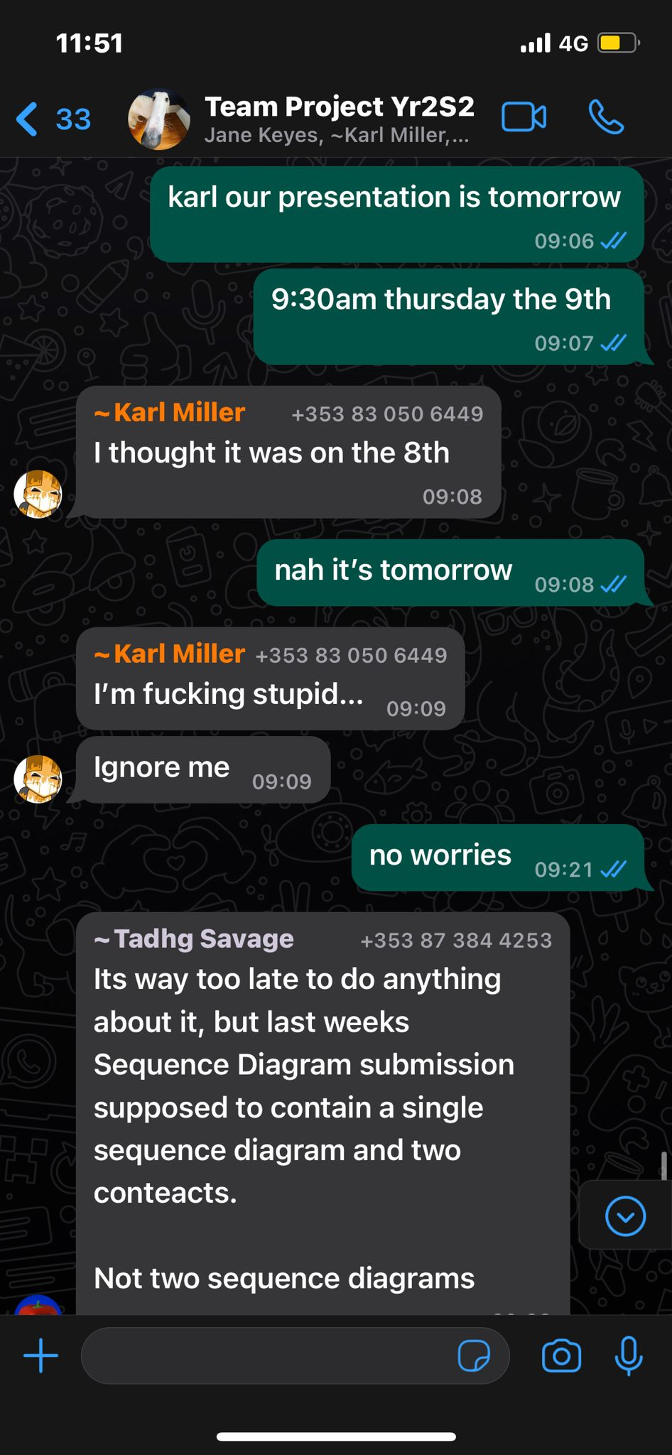

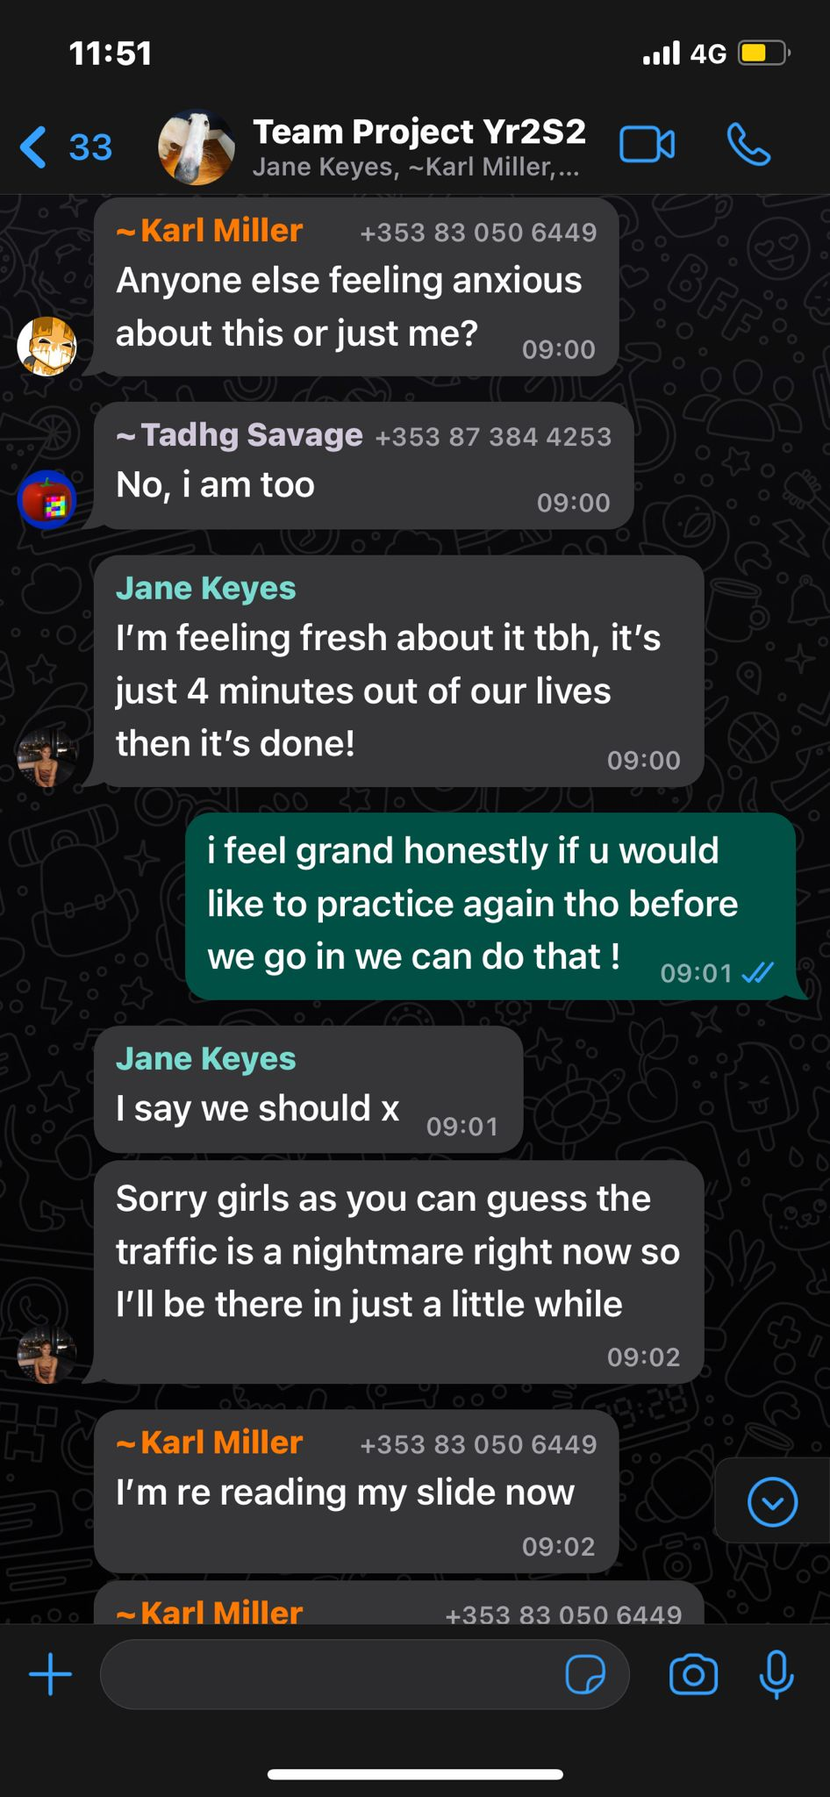

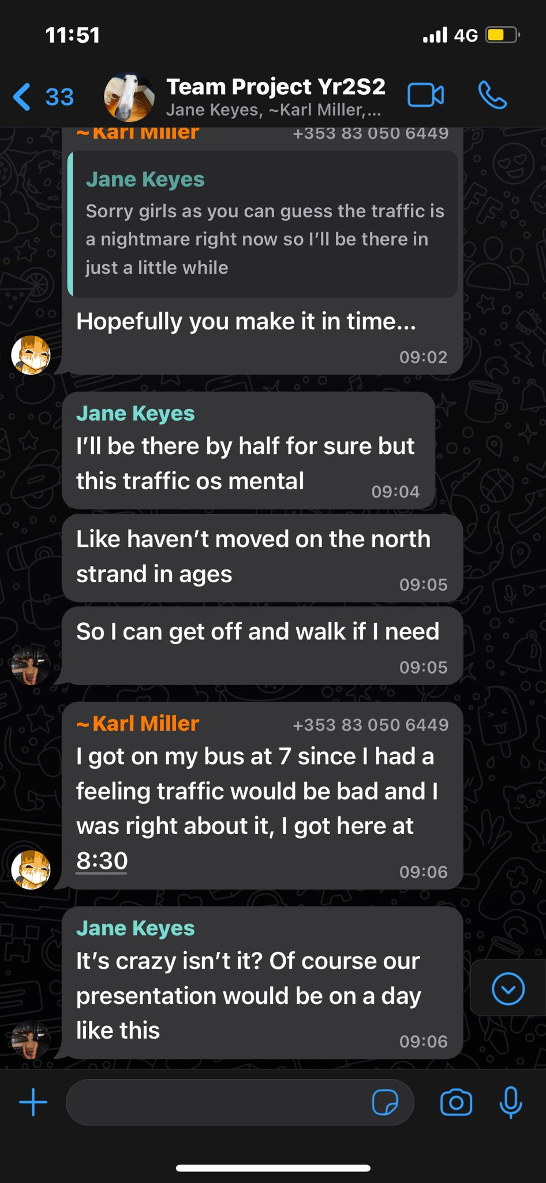

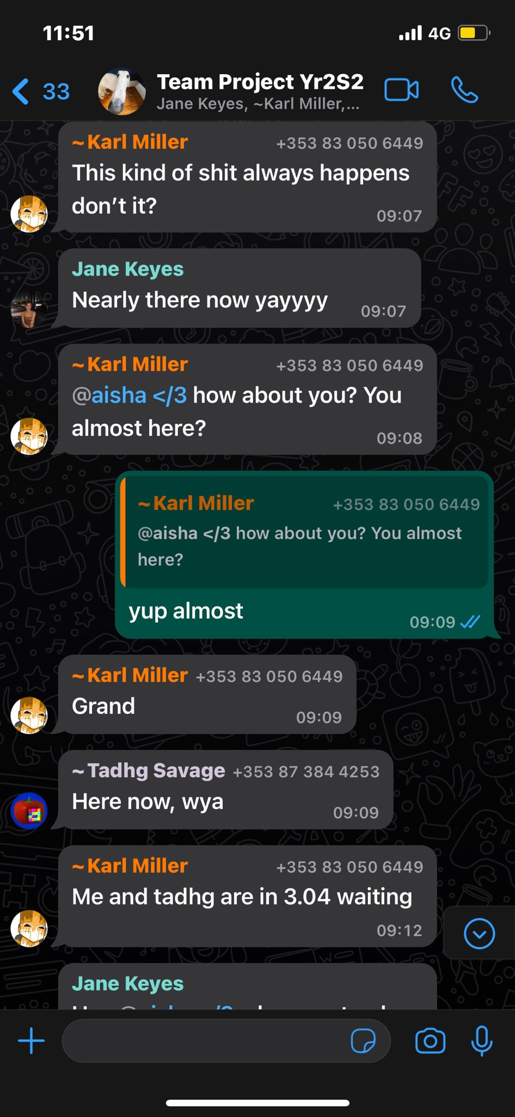

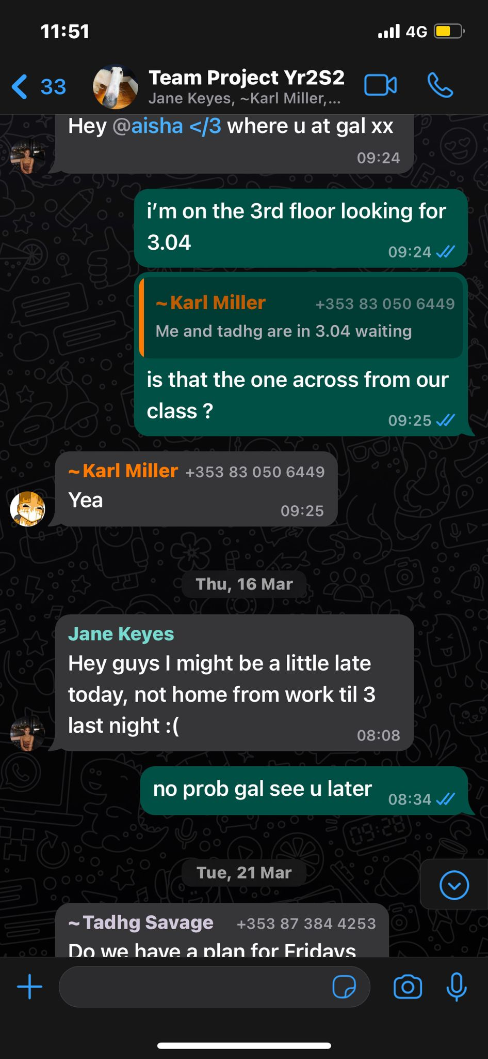

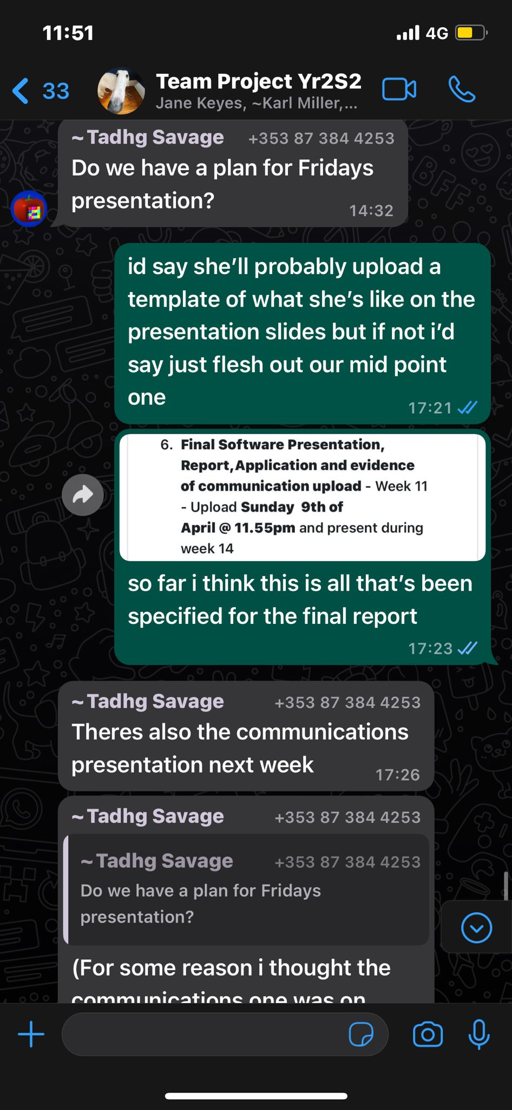

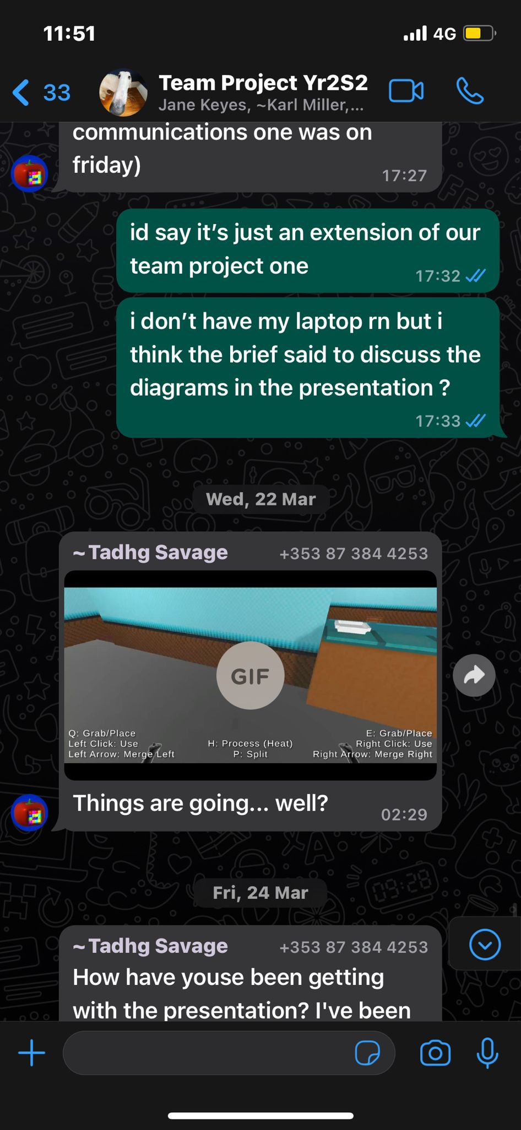

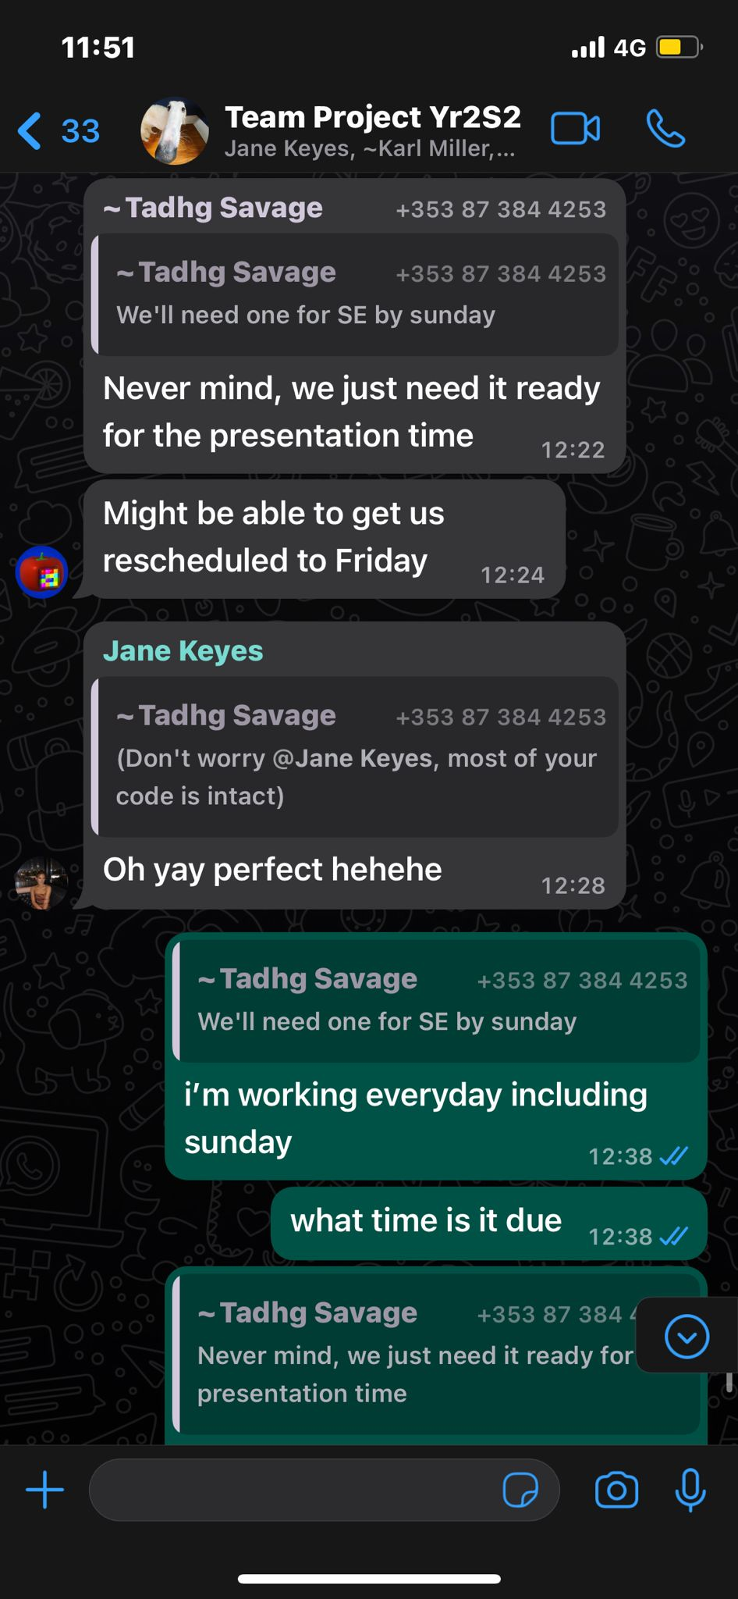

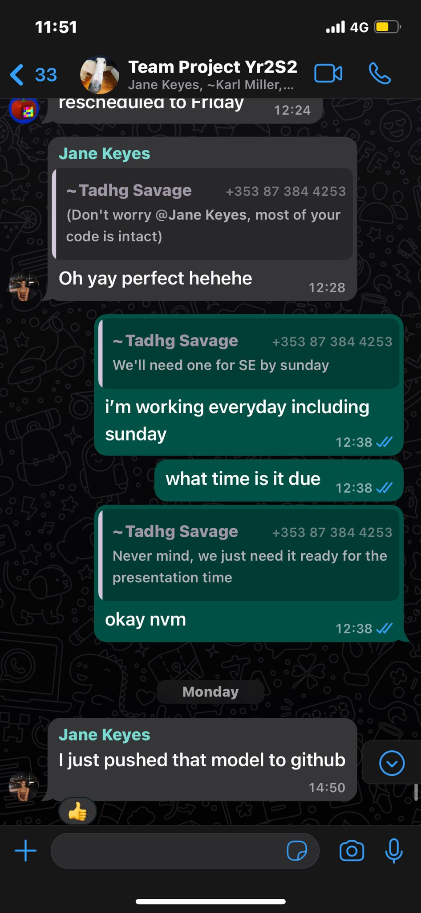

The above are a series of messages sent through our team project group chat via WhatsApp.

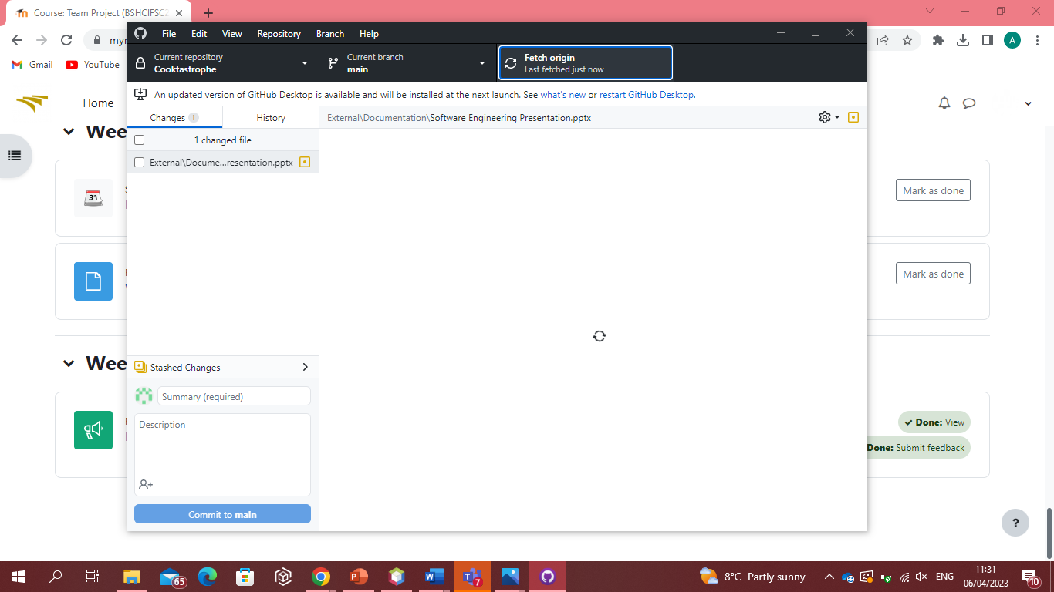

The above is our group’s GitHub repository where we share changes made to files and the game.